A Guide to Maintaining a website

- Simple overview of working with a website Page 2
- What you require on your PC Page 3
- Editing a webpage with Dreamweaver Page 4
- Uploading to the server with Terrapin Page 19
- Editing the News Scroller with Notepad Page 25
- What you will also need to know Page 32

Simple Overview of working with a website.

- Web pages are composed and edited using DREAMWEAVER software

- These web pages are saved onto your PC
– these are the master pages

- Pages are uploaded to your private space on the Freeola server.
This process takes a copy of your masters

- You use an FTP programme called Terrapin to upload your pages which works and looks a bit like Windows Explorer

- Once the pages are on the server they are live and visible to your internet audience.

What you require on your PC

- Dreamweaver software to edit your webpage masters

- A telephone/modem dial up connection. Broadband will not work!

- Terrapin FTP software set up with your Freeola account name and password to allow you to upload to your server

- All of your master webpages and images in a folder structure copied onto your PC. (You should ensure you back these up before ANY change!)

- Windows Notepad to edit the new-scroller messages file

- A graphics package and expertise will be required if you want to change your own pictures. Adobe Image Ready is a good package.

What Kevin needs to do to set this all up for you

- Install Dreamweaver MX
- Copy all Lafour files from CD onto Sue’s PC
- Install Terrapin FTP
- Configure Terrapin to access server using username and password
- Place shortcuts on the desktop to these programs and folders
- Check modem connection to server

Editing a web page with Dreamweaver

Before making ANY change to the master webpages, please make a copy of the existing files, then if anything goes wrong you can start again.

- Go onto the Lafour site and navigate to the page you want to change.

- Make a note of the file name of this page as shown in the browser window

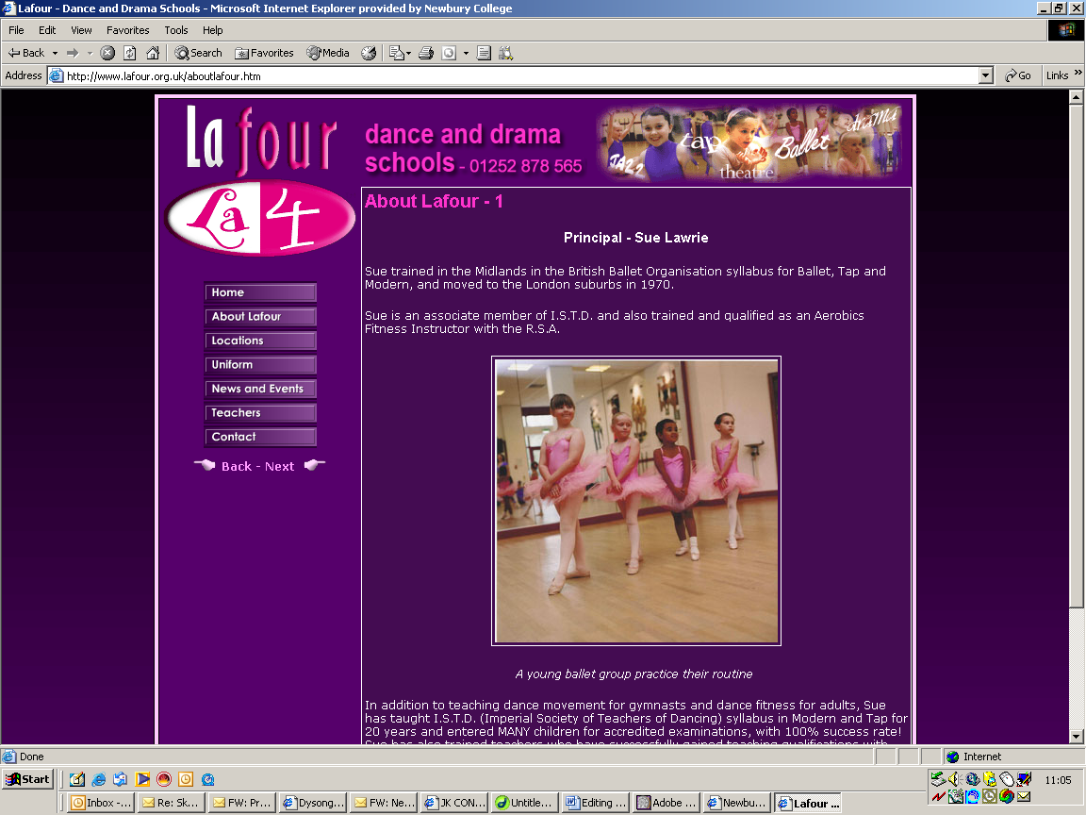

- Run Dreamweaver 

- Make sure that the dual-view (code and page layout view ) icon is selected

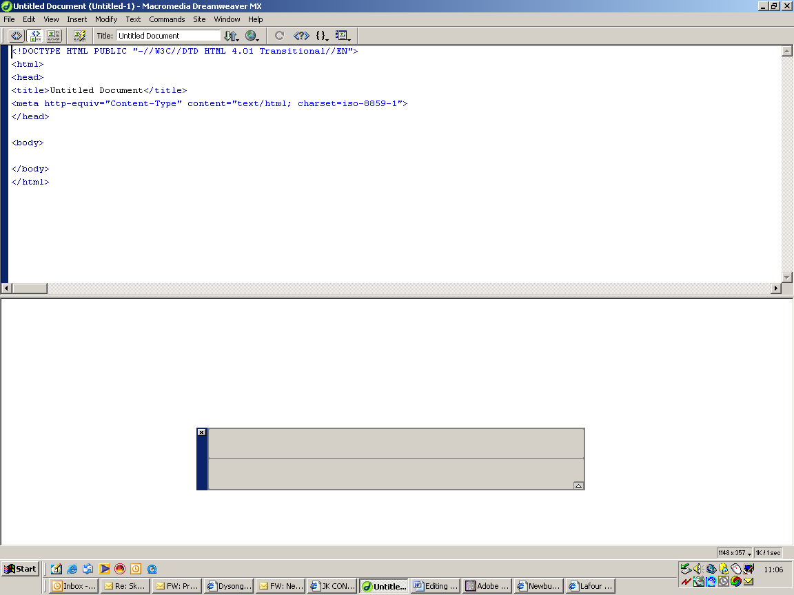

This is where the code is shown and this is where the page layout is shown.

The code is the workings that are behind the page layout you see in the bottom window.

When you do something in one window it also happens in the other window!

- Load in the page you want to change…

File > Open

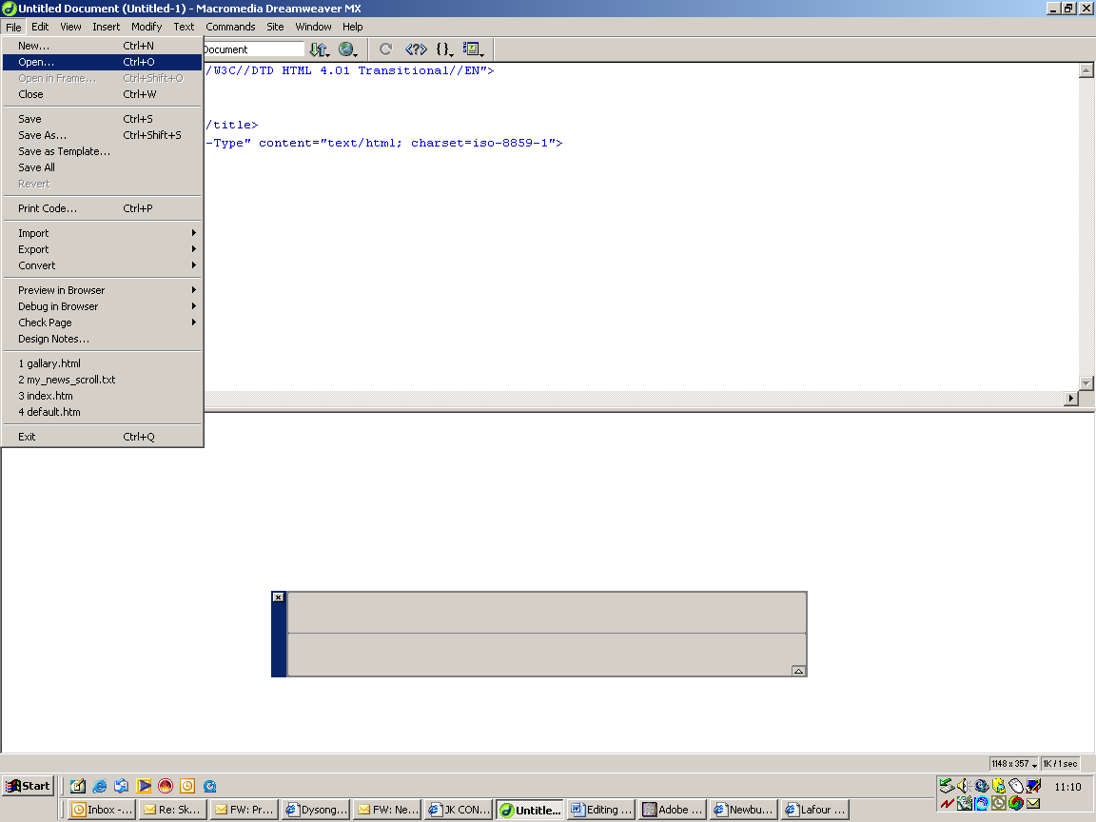

- Find and select the page in your structure

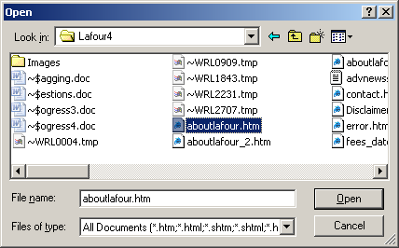

- Click open

- Your page will be loaded for editing appearing as code and layout views

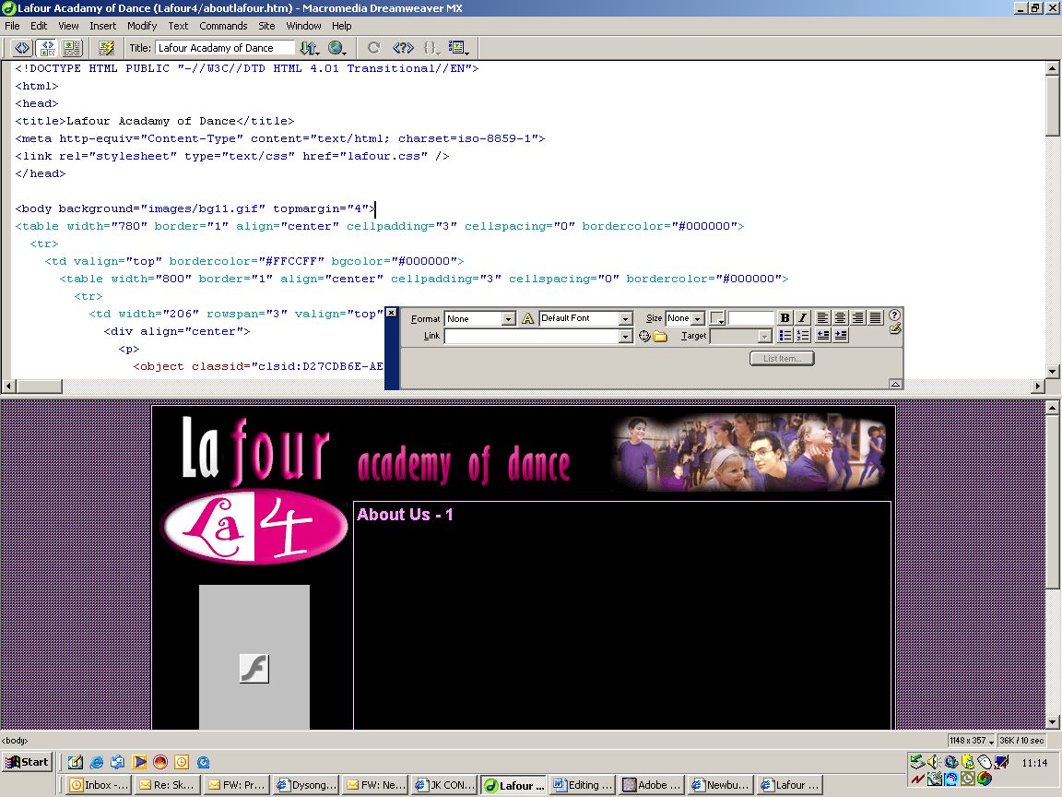

- This ‘floating’ box is called the Inspector.

- The inspector is ‘context sensitive’ which means it changes as you select different objects on the page

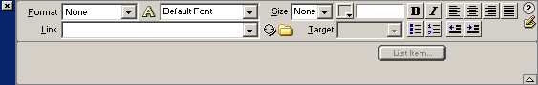

You can use it to change the font, the font size, the font colour, the font boldness etc, but PLEASE DO NOT USE UNDERLINE as underlined text is often confused with a hyper link.

This is where hyperlinks are made

You can also use bullets and numberings and left/right/centre text.

IMPORTANT

In the main it will not be necessary to use the font settings on the navigator as all of the pages are controlled by another means called a ‘style sheet’

You do not need to know about style-sheets at this stage.

But you will have to understand how different colours, fonts and sizes are ‘flagged’ in the code view.

Once you recognise this you will be able to match up the existing styles used on your page.

Here is a very simple example

Lets say you want to change the heading of the page – ‘About Us - 1’

Select this text in the Page layout view – note the text in the code view is also selected!

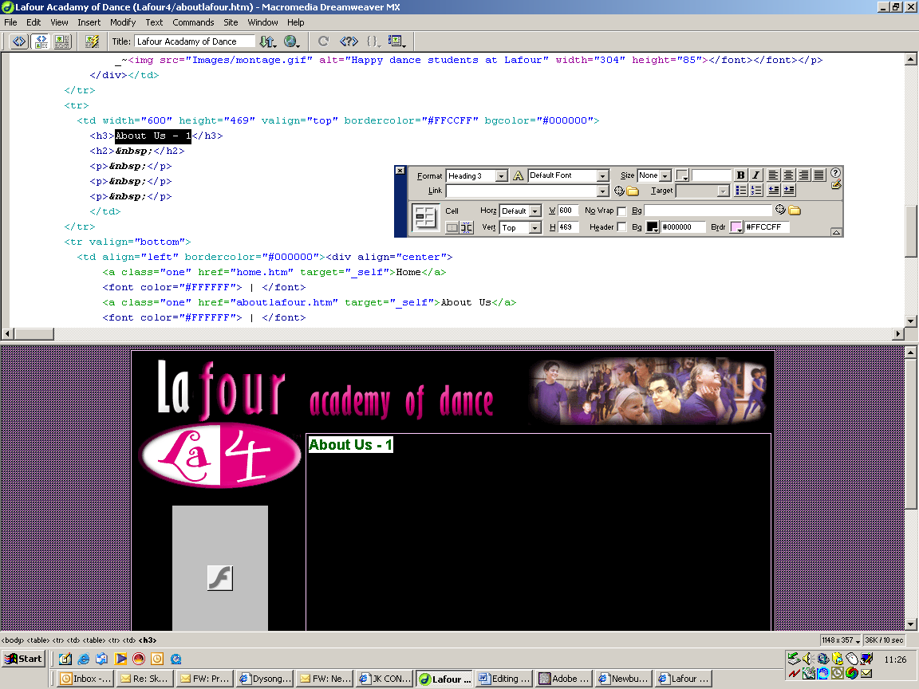

Look very carefully at the code and you will see that ‘About Us – 1’ is encased between two stylesheet flags <h3> which turns on the style and </h3> which turns it off

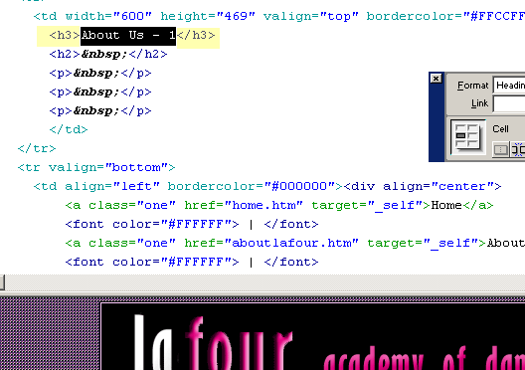

You must make your text changes BETWEEN these two flags in the code view to allow the style to be continued for your edits

eg.. This is correct

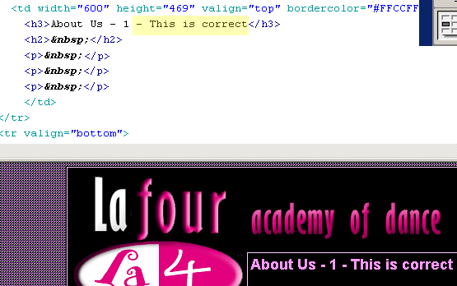

This is the result (make sure you click Page Layout view to see your results)

This is incorrect

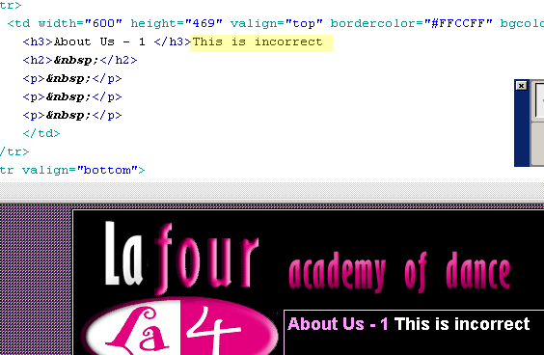

Strange results will occur!

Keep your text edits between the flags!

The flags can be <h1> </h1> <h2> </h2> <h3> </h3> etc

If you need to drop a line, then you can place the code <br> at the point where the line break needs to occur.

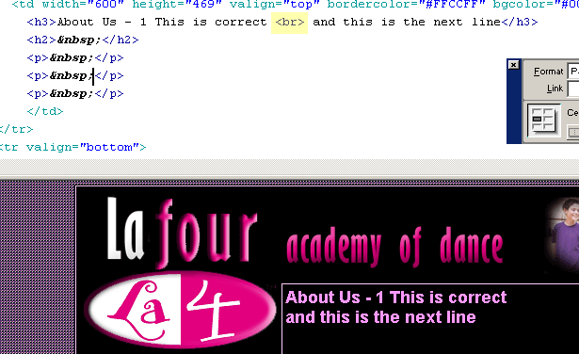

Note that the whole text is still encompassed between the <h3> and </h3> flags.

DON’T TRY TO BE TOO CLEVER OR AMBITIOUS

KEEP YOUR CHANGES TO SIMPLE TEXT AMENDMENTS IF POSSIBLE

IF YOU SCREW UP, THEN YOU CAN START A-FRESH BY DOWNLOADING THE PAGE FROM THE SERVER

- To save your page click File > Save

and ensure the page is saved as the same file name and saved in the same folder so that it over-writes the original

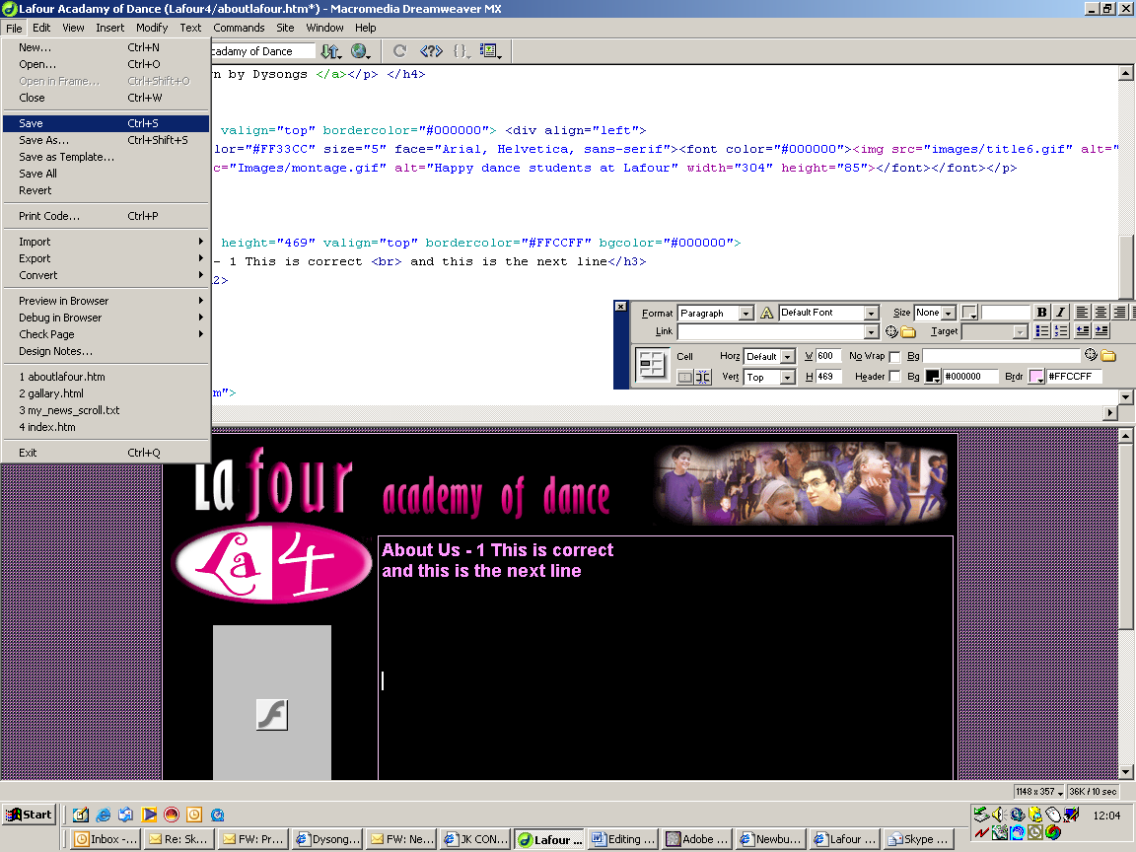

Your Page is now ready
to be uploaded to the server

Uploading to the server with Terrapin

This part of the operation is necessary so that your internet audience can see your pages and pictures.

It is also required when changing messages on the news scrollers or when changing a picture

To do this you will use a piece of software called Terrapin which allows you to log onto and see your server space and see your master files on your PC at the same time.

You will then be able to ‘drag and drop’ files from your PC into your server space, so that a copy of the file appears on the server.

You can also drag files from the server back to your PC

NB.

YOU MUST MAKE SURE YOU ARE ALWAYS AWARE OF WHETHER YOU ARE -DRAGGING FILES FROM YOUR PC
OR
DRAGGING FILES FROM THE SERVER!

OTHERWISE YOU WILL BE IN A TERRIBLE MUDDLE!!!!

IMPORTANT!!!

Any file name you save MUST be lowercase as your server will not work with files containing upper case letters in their file names

- Make sure your modem cable is plugged into your telephone point.
You may have to remove your Broadband connection from your telephone wall skt for this

- Click the Dial up icon for Lafour 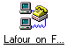

- This window will be displayed

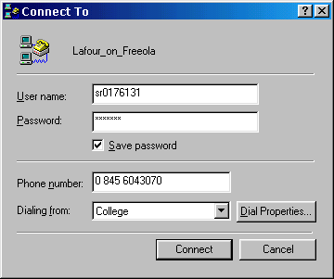

Note the username sr0176131

Note the password (not shown) newsite

Note the telephone number 0 845 6043070

You must use lowercase letters only!

This should already be filled in for you.

Click Connect to connect directly to Freeola’s server and to your private server space

- Your PC will connect after a few minutes to your serverspace.

- Run Terrapin FTP 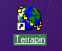

- The programme will display this screen

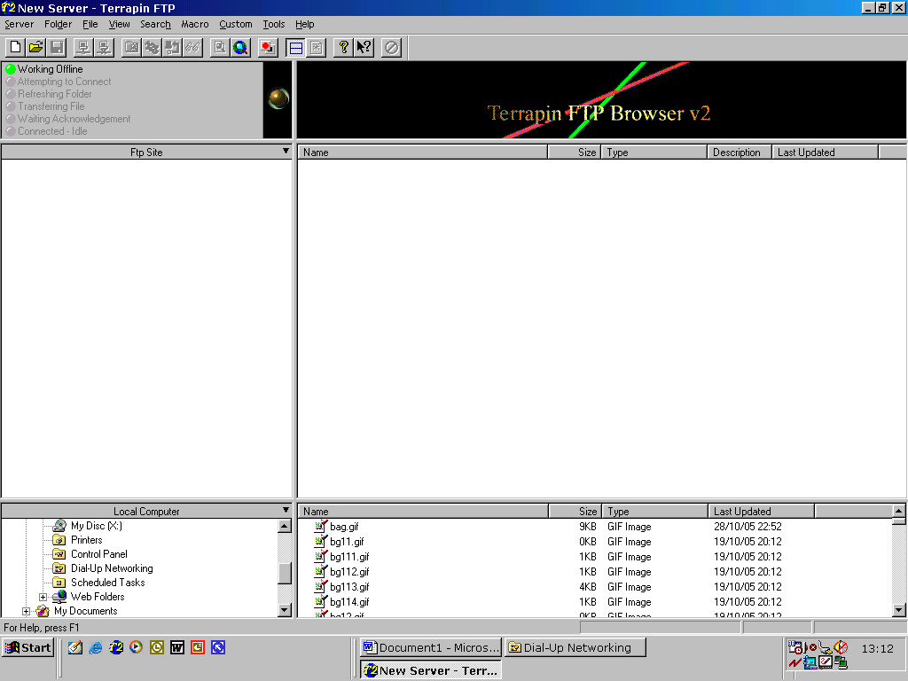

- You now need to open your private server space

Server > www.lafour.org.uk.svr

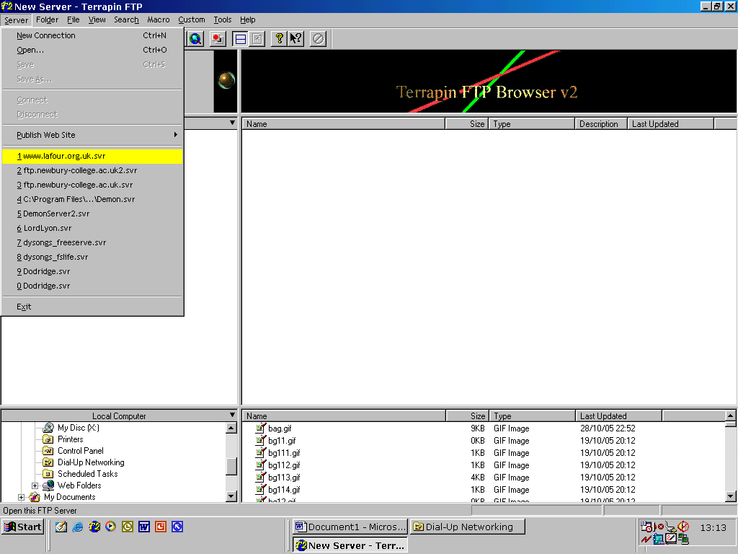

The programme will load up your server space in the top right window
It is from here that people can see your website files

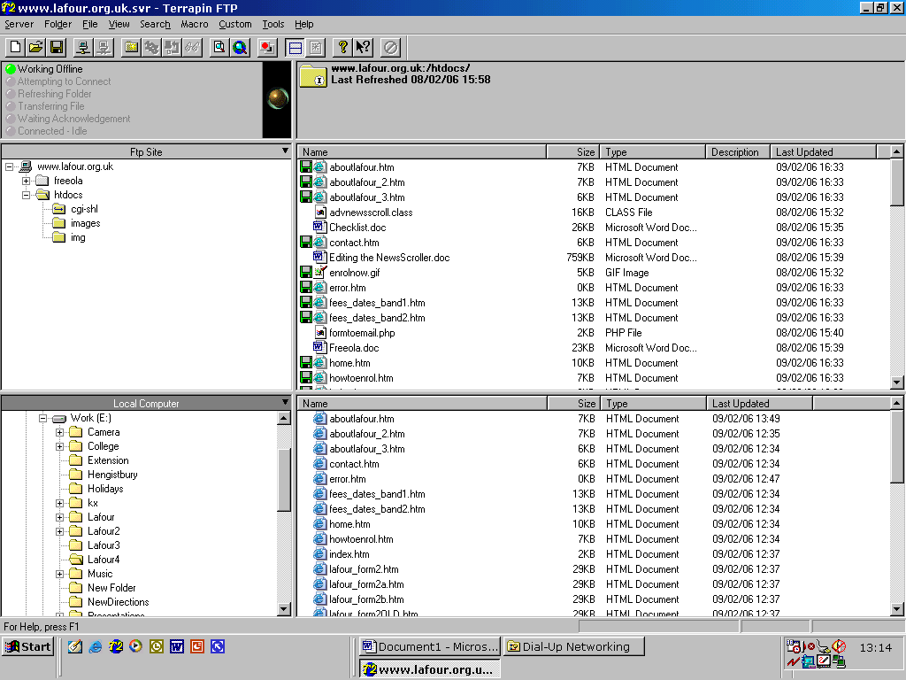

The bottom window is where your PC is keeping your master files. You may have to navigate using the bottom left window to see your files.

Note that the open folder icon displays it’s contents on the right part of the screen

Now simply click, hold and drag the file you want to upload from the bottom window to the top window white-space area and release the mouse button and the file will be copied across to the server

You can also drag files back from the server to your PC (the opposite direction) if you want to replace a file on your PC with the version that is on the server.

WARNING
Be careful only to over-write the files you really want to!

Editing the NewsScroller

Overview.

- The NewsScroller uses a simple text file on the server.

- The text file may be changed at any time to update the information displayed by the NewsScroller

- The name of the text file is my_news_scroller.txt
(Note file name is all lower case!)

- You must edit this file with a simple windows editor called Notepad
Start > Programmes > Accessories > Notepad

- This text file already resides on your PC.
This is the MASTER file which you make all of your changes to

- Once you have changed the file to show new information, the file must be uploaded to the server and this overwrites the previous version.
The news program reads from it to display your information

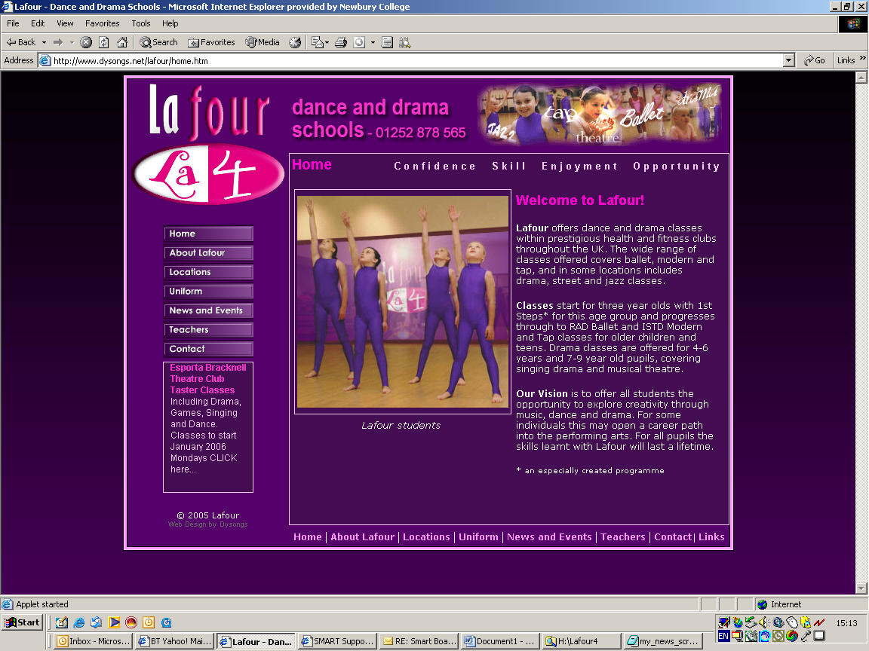

The NewsScroller

The Text File my_news_scroller.txt

- This file has a format which must be observed and obeyed to work.

- There are 4 elements to each news article

  - Element 1: The title of the news article

  - Element 2: The short blurb of the news article

  - Element 3: The hyperlink URL to the page the article
(optional) jumps to

  - Element 4: Browser Window (whether you use the
(optional) same browser window to display the page
you have hyperlinked or whether you use a
new window

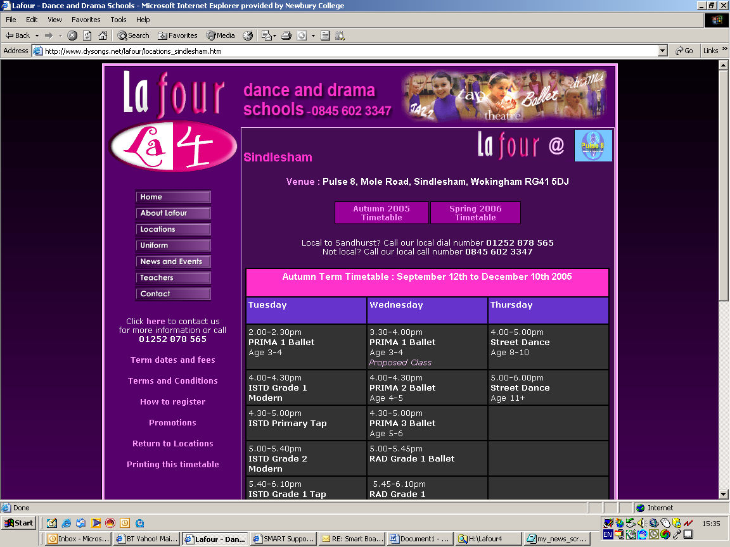

- Each of these 4 elements are represented by a line in the ‘my_news_scroller.txt’ file

- Each element must be separated by a ‘bar’ character |
which is found to the right of the keyboards left Shift key

- Here is a typical layout of a single news article.

Special Offer | Free taster courses CLICK HERE… | tastercourses.htm | _blank

Explanation….

Special Offer will appear in bold type and coloured bright pink

Free taster courses CLICK HERE… will appear in normal type and pale pink

tastercourses.htm is the URL of an existing page on the Lafour website

_blank signifies that the page is to be opened in a new browser window

Here is sample of the text file of the news scroller as displayed in Windows Notepad.

Free Taster classes at Kingston|Lafour will be running free taster dance classes at Esporta on Wednesday September 14th More>>|promo_kingston.htm|_blank
Read our latest Newsletter|Catch up on all our latest news More>>|newsletter.htm|_blank
Nottingham free tasterclasses|Check out and enrol for free taster dance classes at David Lloyd on Monday August More>>|locations_westbridgeford.htm|_blank
A Lafour Dance Academy near to you!|We run dance classes throughout the south east and beyond! ||
Try a Street Dance class free at Wokingham|Friday 16th September - Free Street Dance session at Holmes Place More>>|promo_wokingham.htm|_blank

- Each line is a news article and these are separated by the bar (shown in red)

- There can be as many lines (news articles) as you like

- If there is no page to hyperlink to ( i.e. a news article is just a message with a title and a blurb) then omit the URL and the browser option as shown in the second to last line (see below)

A Lafour Dance Academy near to you!|We run dance classes throughout the south east and beyond! ||

- Note that the bars will be seen as black bars and not red. Also that some news articles’ text may spread over two or more lines in Notepad. This makes the lines just a little more difficult to read, so careful observation is called for before you change the data.

- Below is what you may actually see

Free Taster classes at Kingston|Lafour will be running free taster dance classes at Esporta on Wednesday September 14th More>>|promo_kingston.htm|_blank
Read our latest Newsletter|Catch up on all our latest news More>>|newsletter.htm|_blank
West Bridgeford - Nottingham free tasterclasses|Check out and enrol for free taster dance classes at David Lloyd on Monday August 22 More>>|locations_westbridgeford.htm|_blank
A Lafour Dance Academy near to you!|We run dance classes throughout the south east and beyond! More>>|locations.htm|_blank
Try a Street Dance class free at Wokingham|On Friday 16th September Lafour will be running a free Street Dance session at Holmes Place More>>|promo_wokingham.htm|_blank

Once you have edited and checked your file, you must save it. File > Save

Now upload the file to the server and your new information will be displayed by the news scroller.

What you will also need to know how to do

I will prepare helpsheets to go into this section as you require them. The first (Hyperlinking) is already done

Hyperlinking

- A hyperlink is simply the URL (web address) of another page

- To make a hyperlink to another page in Dreamweaver select the object that is to become a hyperlink – this can be a picture or text.

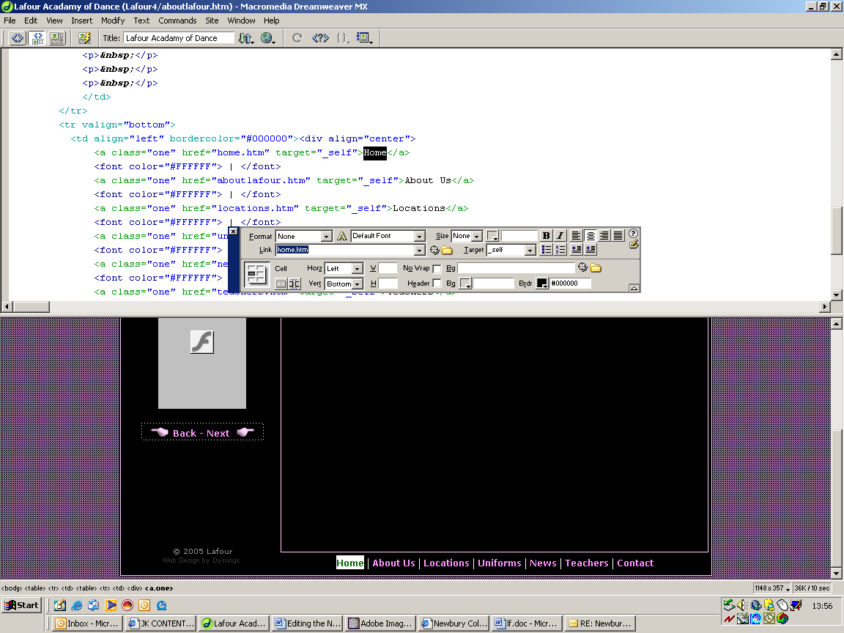

Then fill in the file name of the page in the inspector

If it is a hyperlink to an external site then fill in the full web address

e.g. http://www.newbury-college.ac.uk

Don’t forget you can copy this address from the browser‘s address bar (Ctrl C) and paste it (Ctrl V) into the link field on the inspector

