Session 4

Advanced features of Yahoo email

Remember….

- To get to your email you will need to log on to Yahoo’s website and log in to your account.
- Your email address is
Your Yahoo ID is
Your password is
Your account is held on www.yahoo.com

Note all lowercase (non capital) letters

You should learn and remember your email address, your ID, your password and the website where your account is held!

Note, your email is private to you and
only you can read your emails and send your emails

No one else can!

The following sections will show you how to use some of the more advanced and useful features of Yahoo email

- Spam
- Filing and folders
- Attachments
- Searching through your email

- Setting up a email distribution list

  - Spam

    - Spam is unwanted and un-solicited advertising email sent by somebody (usually anonymously) to you.
    - The term Spam Email is derived from the use of the word Spam in the Monty Python sketch Spam Spam Spam, in which spam, a type of tinned mechanically reclaimed non-specific meat sponge product, was listed on a greasy spoon café menu as

Spam and Chips
Spam egg and chips
Spam egg chips and spam
Spam spam egg chips and spam
Spam and spam
Spam spam and spam with chips etc

i.e. spam is worthless, over-abundant, and disposable!
You get the meaning???!!!!!

    - You may find you receive a lot of this at times and you should know how to deal with it.

    - The Yahoo email system you are using is intelligent to understand that if you decide to mark an email as spam then it will try to deflect all emails sent FROM this address and all emails similar to it, automatically into the Spam email bin.

    - Spam email will stay in the bin for 30 days and will then be automatically removed

Here is a typical spam email in the inbox

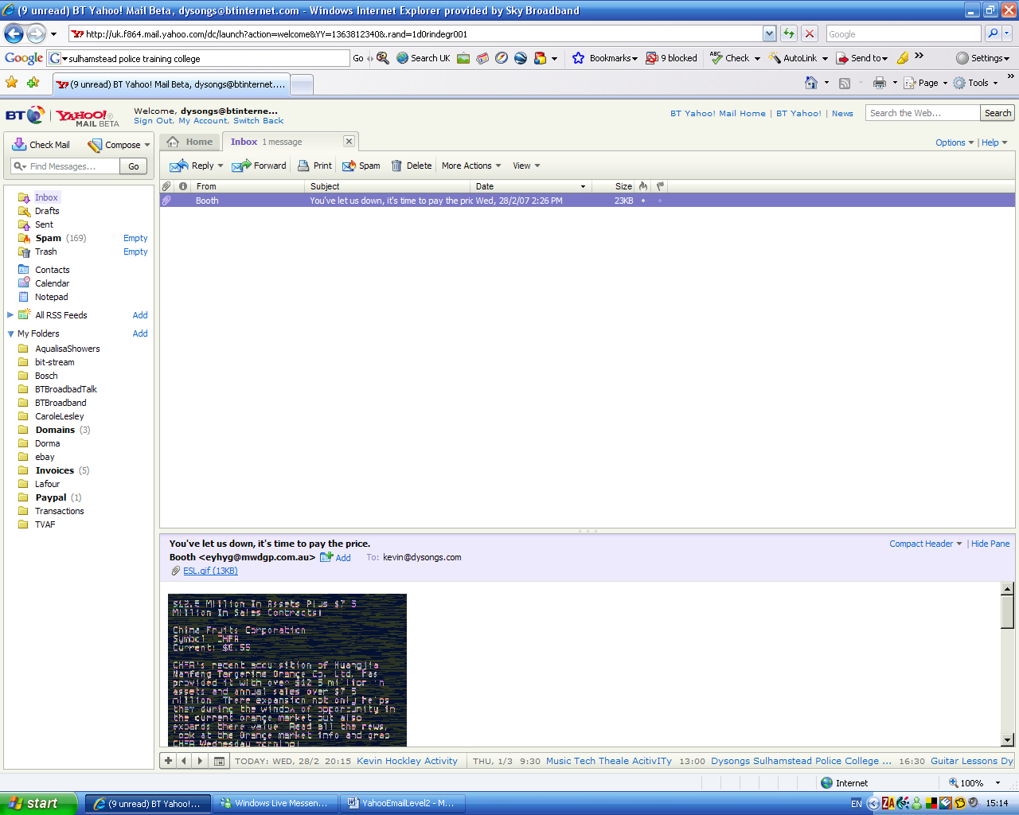

Note the content of the spam email is shown in the preview pane – this spam email contains a picture with writing on it which is the spammers’ (i.e. the person that has sent the spam)latest approach to try to get past the automatic junk email mechanisms.

The spammer has succeeded in getting his spam email through this time because as the text is part of a picture and is not detectable typed-in text

- If possible do not open the spam email as by doing so you could trigger a confirmation from your computer back to the spammers computer letting him know you are a live email target, and thus you will be sent even more spam.

- It is perfectly okay to preview it in the preview pane as this does not mean you have opened it

- So through the preview pane you have detected that the email is a spam and you wish to get rid of it.

Make sure that the spam email is highlighted in your inbox (in purple below)

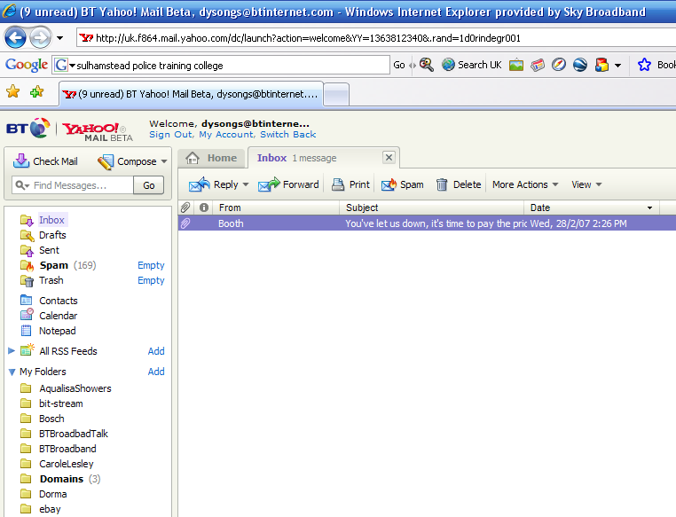

Now click on the Spam button and the spam will be labelled as such and sent to your Spam folder. It will also disappear from your inbox.

- Filing and folders

Remember that Yahoo gives you a finite amount of space for your emails – each email will take up a little bit of that space. How much depends on the size of the message you receive and the message you send

Folders and boxes

  - Your email is always filed for you.

  - Your email is filed in containers called boxes or folders which are shown down the left hand side of the screen – very similar to the drawers of a filing cabinet
  - Every email you receive is shown in your Inbox
  - A copy of every email you send is kept for your reference in your Sent box. This is sometimes very useful as it records and confirms the fact you did send the email to that contact, on that date and shows what you actually wrote.
  - Spam email is filed in its own folder so that it no longer imposes on the email you have received in your inbox. Note that you can manually empty the spam folder if you want to

  - Trash is filed in its own folder to and also no longer imposes on the email you have received in your inbox. Note that you can manually empty the trash folder if you want to

How the Draft folder works

  - If you break off from composing an email because of an interruption
and need to close your email down for some reason, your unfinished email will be filed in the Drafts folder.
When you wish to resume composing this email, you can open the Drafts folder, click on the draft email and then carry on composing until it is finished. You can then click on the Send button and the email will be sent as normal.

  - The email will no longer be seen in the Draft email folder

Extended filing method for your emails

  - If you receive a lot of email, it is sometimes useful to set up your own extension of the Yahoo filing system – i.e. you can add and use your own sub-folders.

  - A sub folder holds the emails from your inbox which you have chosen to keep in that sub folder

  - You will be asked to provide a name for the folder before it is created. Try to make all your folder names meaningful to you.

  - Once you have moved an email to a folder, it is no longer seen in the inbox.

  - This helps to keep your Inbox lean, but you need to remember to look in a folder if you need to read a particular filed email, once you have filed it

In the following scenario lets say that you have received email and want to file it in a folder called Email Training

The inbox has 2 emails waiting to be read and filed into the Email Training folder

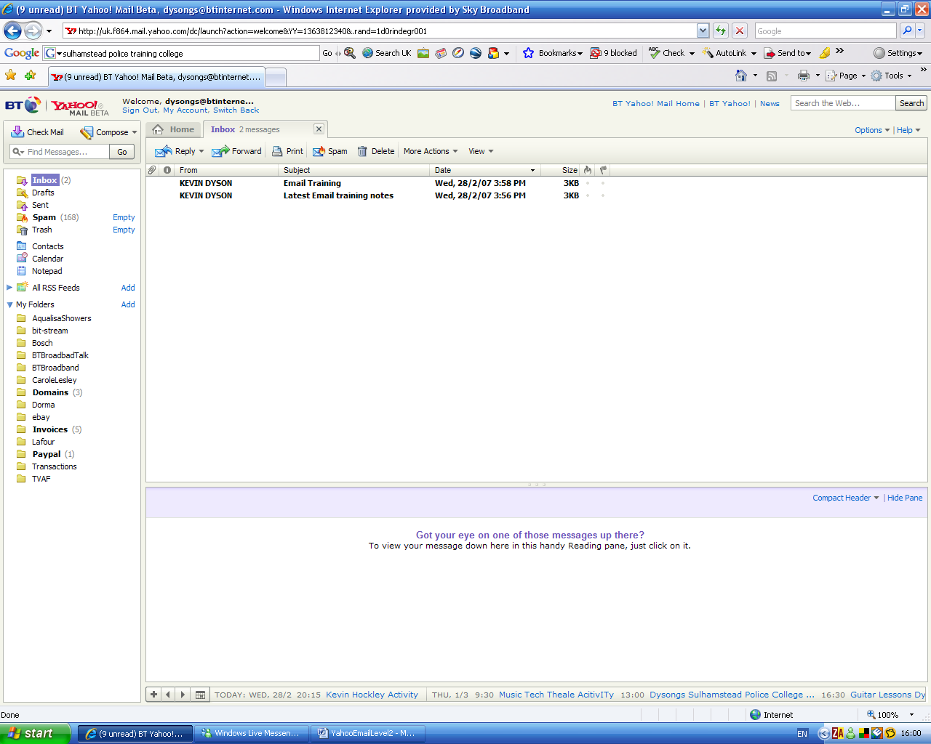

First double click on an email to read it

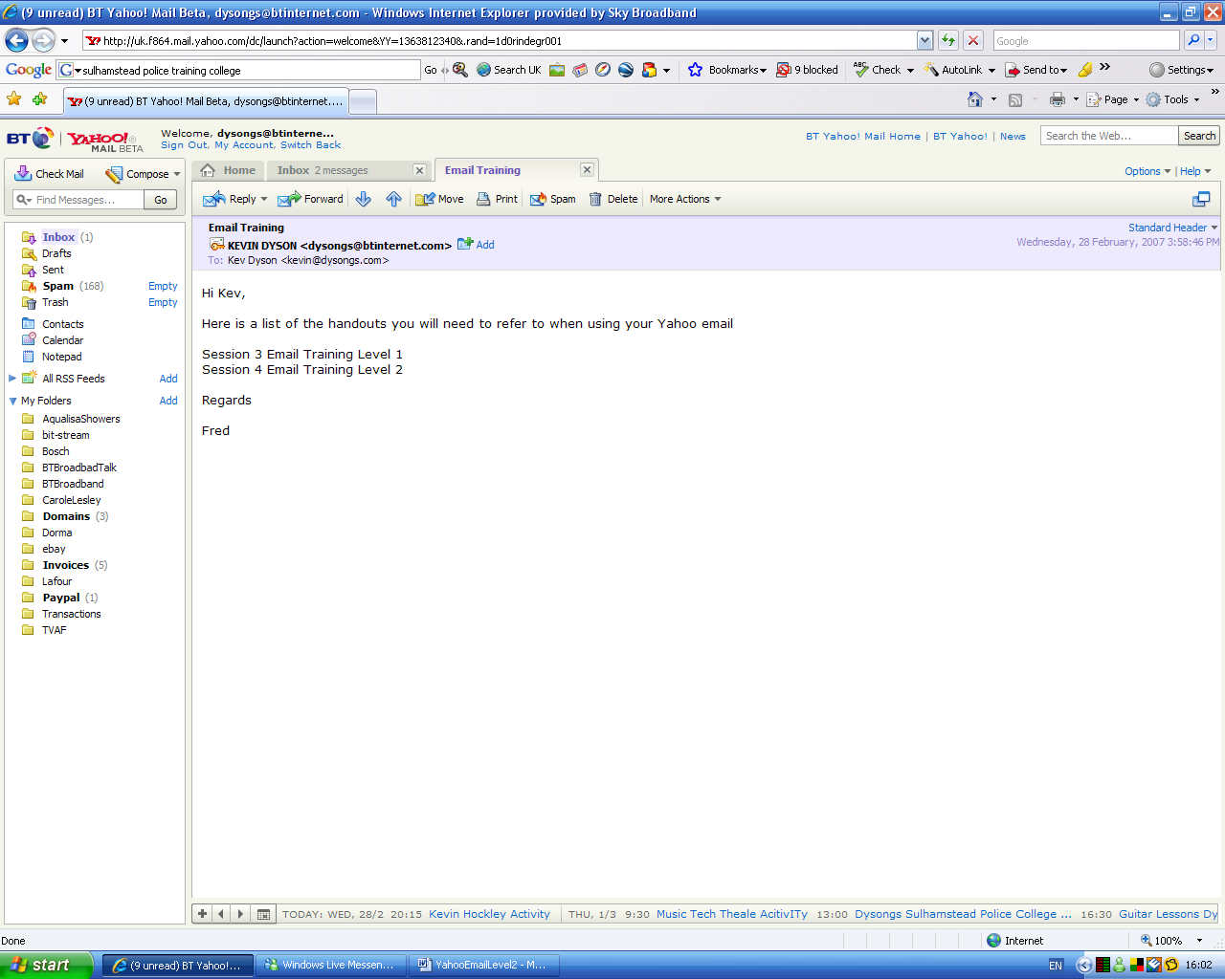

Creating a new folder

At this point you may decide you want to keep it in a new folder called Email Training

A list of existing folders is displayed here, but there is no Email Training folder yet

So before you can move the email into the Email training Folder you must first CREATE the email Training folder

To do this click Add by the side of My Folders

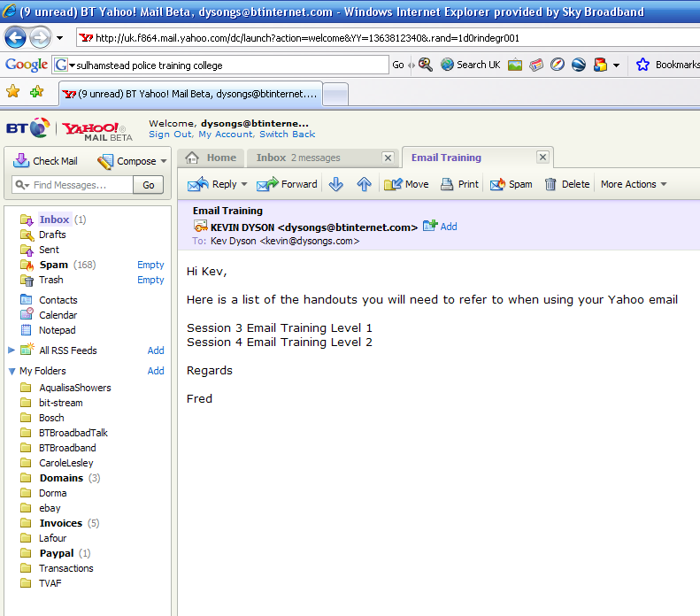

A new (as yet untitled) folder will appear at the bottom of the list
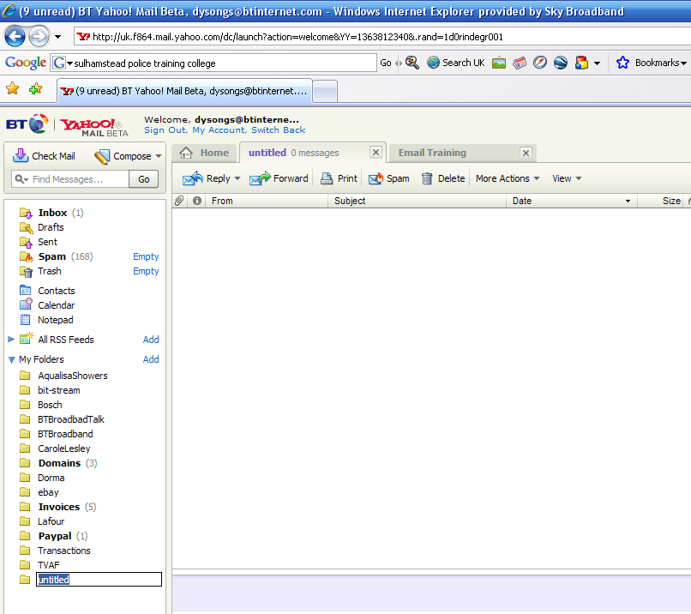

Type in the name of the new folder Name (Email Training)

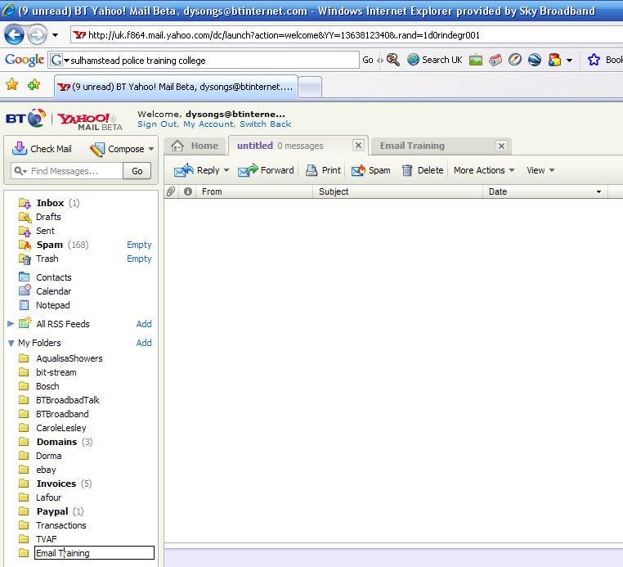

Press Return and the new Email Training Folder is created and appears alphabetically in your folders list

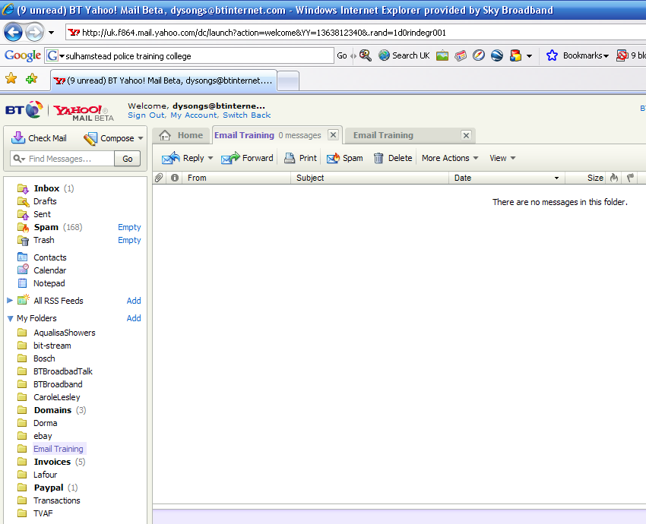

Your new folder is ready to be used for filing all of your Email Training emails

Moving an email to a folder

Now that your Email Training Folder is created go back to displaying the Inbox where your email is listed

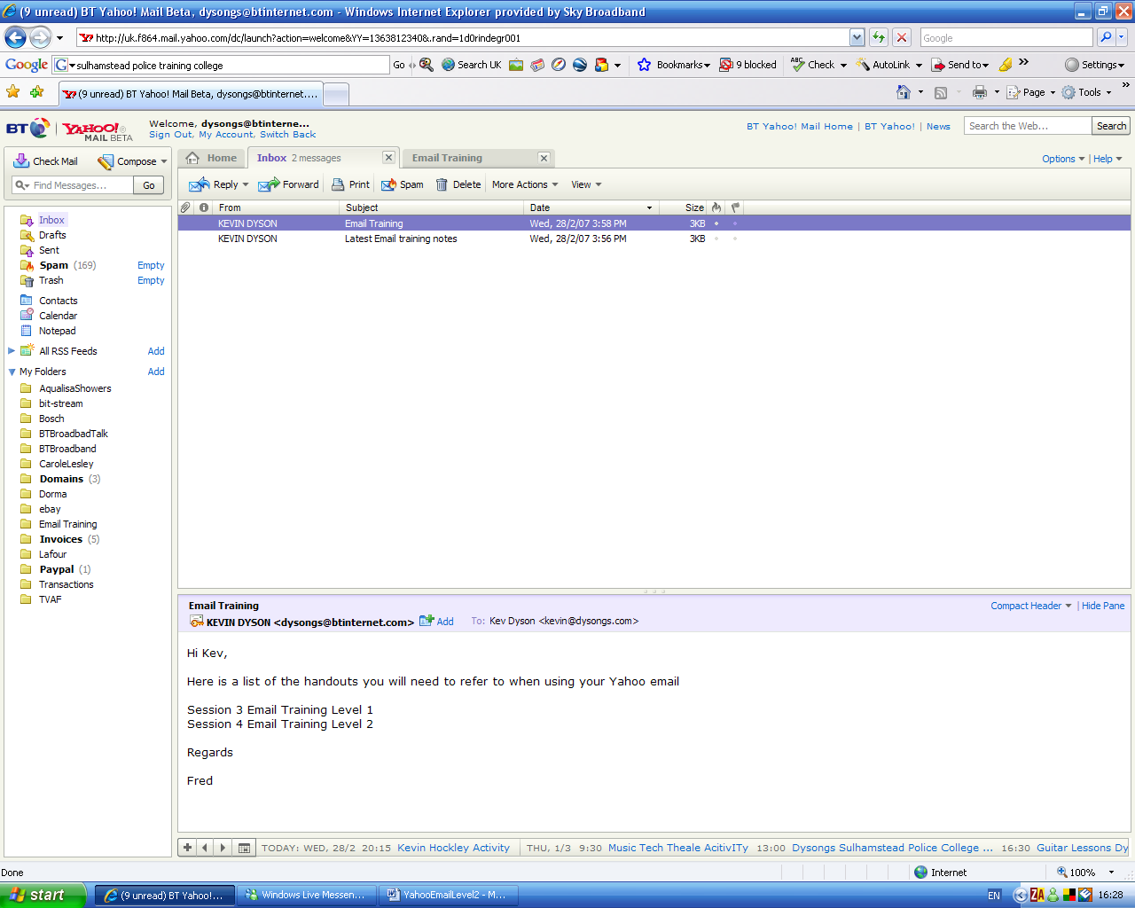

With your mouse click on the email with the left button and keep it held down while you drag the mouse cursor down the list of folders.

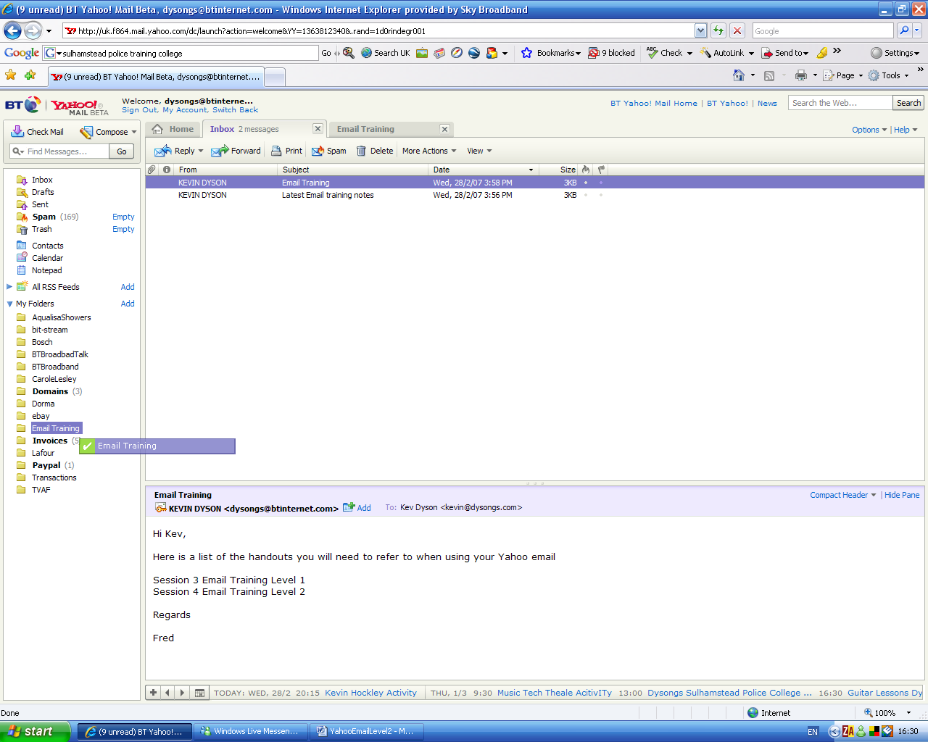

As your cursor moves down the list of folders, each folder in turn will be highlighted.

When the Email Training folder becomes highlighted, release the mouse button to drop the email into the folder

As you drop the email into the folder, it will no longer show itself in the Inbox.

To check that the email has arrived safely in its new folder simply click on the Email Training folder to reveal its contents

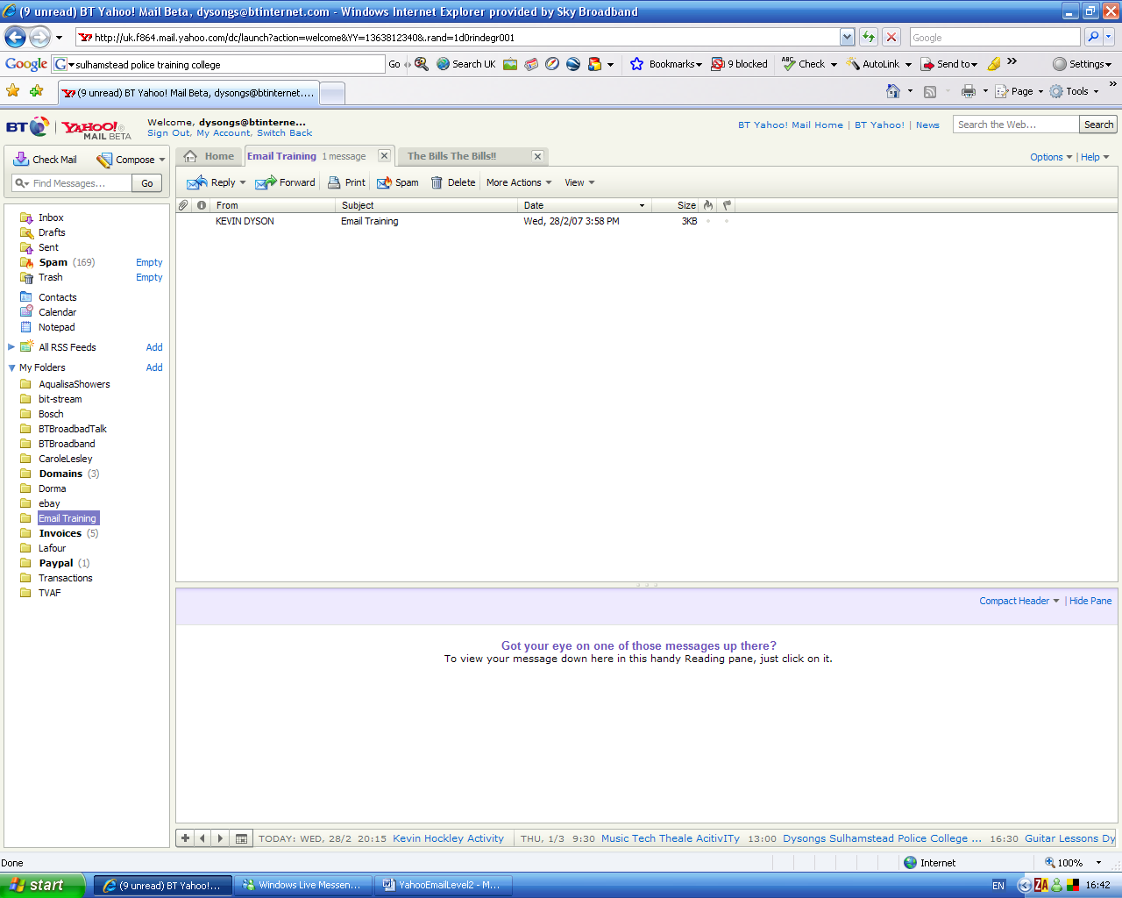

Notice that Email Training folder is highlighted in the left hand pane

Note – Don’t forget to click on Inbox to switch back to your Inbox view!

You can move emails from folders into different folders by the same method.

- Click the folder in the left hand pane to display its contents
- Click, drag and drop the email into another folder

You can also move things back to the Inbox using this method, or even recover things from Trash or Spam back into the inbox should you need to.

  - Attachments

    - An email is a container. Most of the time an email will contain just text, so when the email is opened the text can be read
    - An email is also capable of containing other objects as well.
Such ‘objects’ might be..
      - a Word document
      - a picture file
      - a photograph file
      - a song file
      - a video file
      - a sound file
      - a programme file
      - a game file
      - a text file
      - an animation file
      - a database file
      - a Excel spreadsheet document
      - a Powerpoint presentation document
      - a Publisher document

- Attachments must be opened to see or hear them

- Emails are also capable of displaying embodiments- pictures, and hyperlinks to websites and email addresses. These types of embodiments are ‘embedded’ into the emails and are not attachments as they are displayed within the body of the email text and can be seen unaided.

- A serious word about attachments
Attachments are very useful as they allow one user to send things (other than just text) to another user through email.

But it is through attachments that most viruses and trojans infect computers.

If you receive an email with an attachment in it, before you open it ask yourself the following questions…

- Do I know and trust this user?
- Am I expecting an email with an attachment inside

If the answer is yes, then you may feel you are safe to open the attachment

If not do not open the email and certainly do not open the attachment

SEND THE EMAIL TO THE TRASH BIN AND EMPTY THE TRASH STRAIGHT AWAY! THE ATTACHMENT IS MOST PROBABLY A VIRUS!

Sending an attachment with your email

In the following scenario, let’s say you want to send a picture to a friend you are emailing.

- Compose the email as normal. You might like to also include “Please see the attachment” in your text.
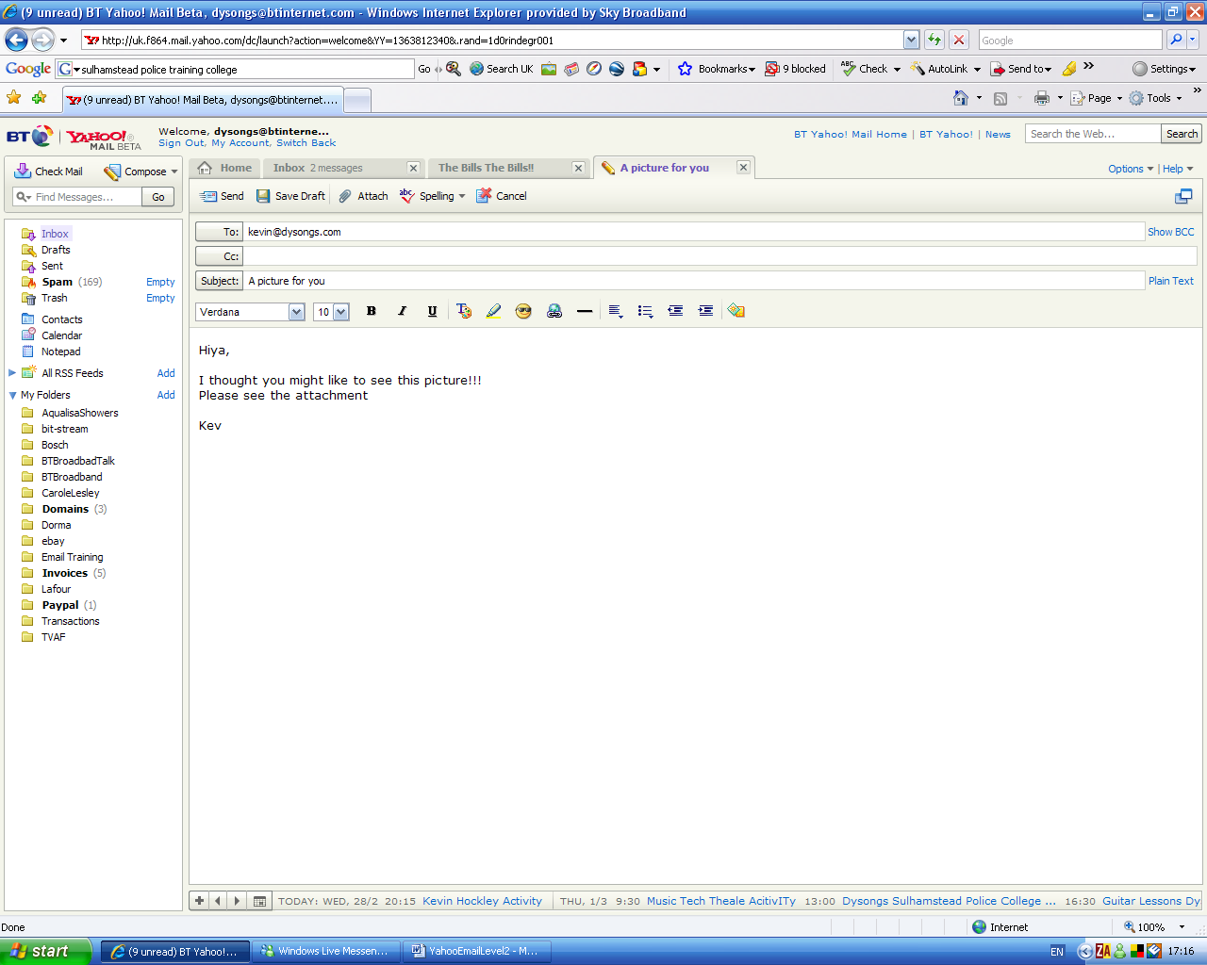

- You are now ready to attach your picture.

- Make sure you know beforehand roughly where your picture is stored on your PC, because you will need to find it!

Click the Attach button
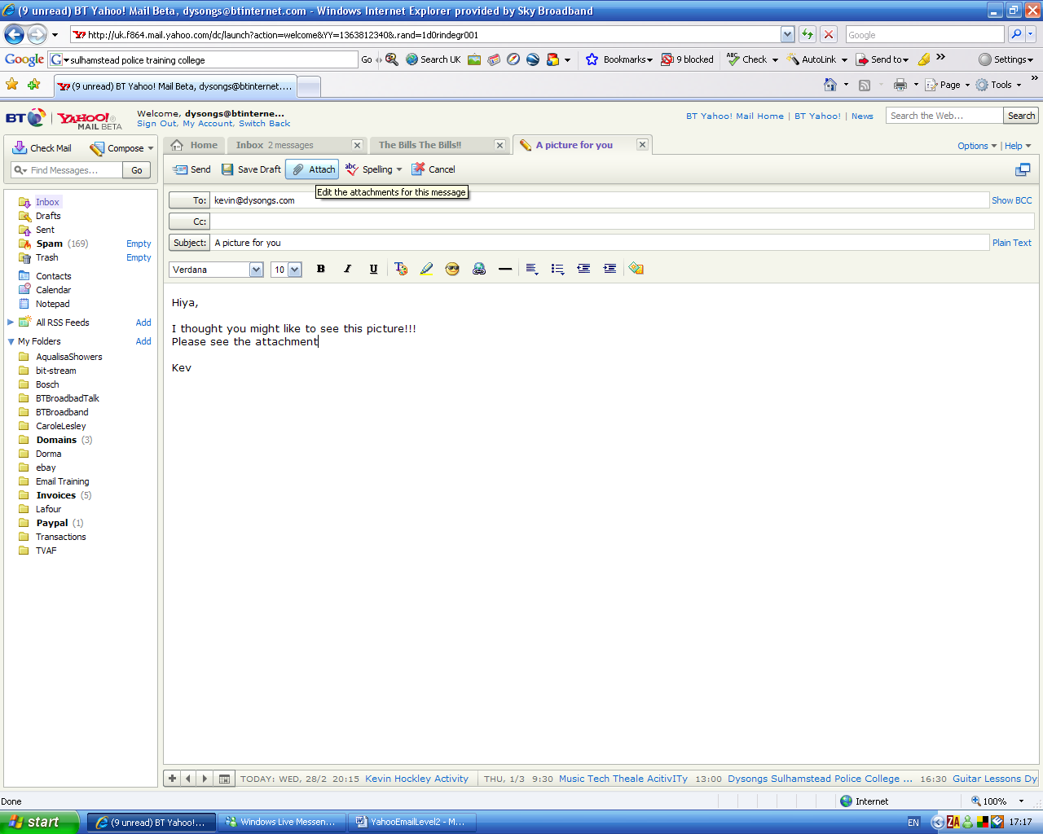

An explorer window will open

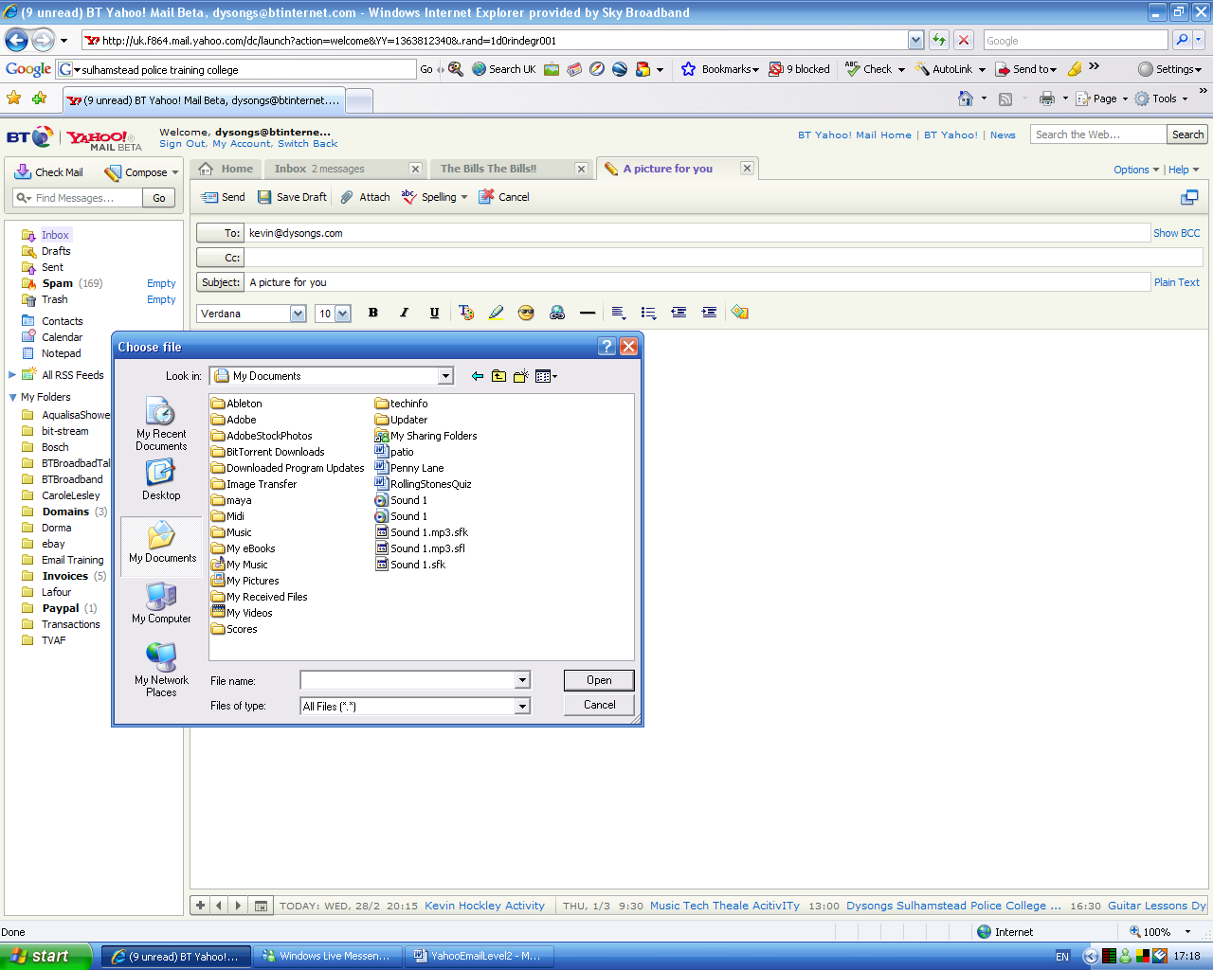

You must now navigate to the folder where your picture is kept

When you have found the picture by navigating through the folders, select it

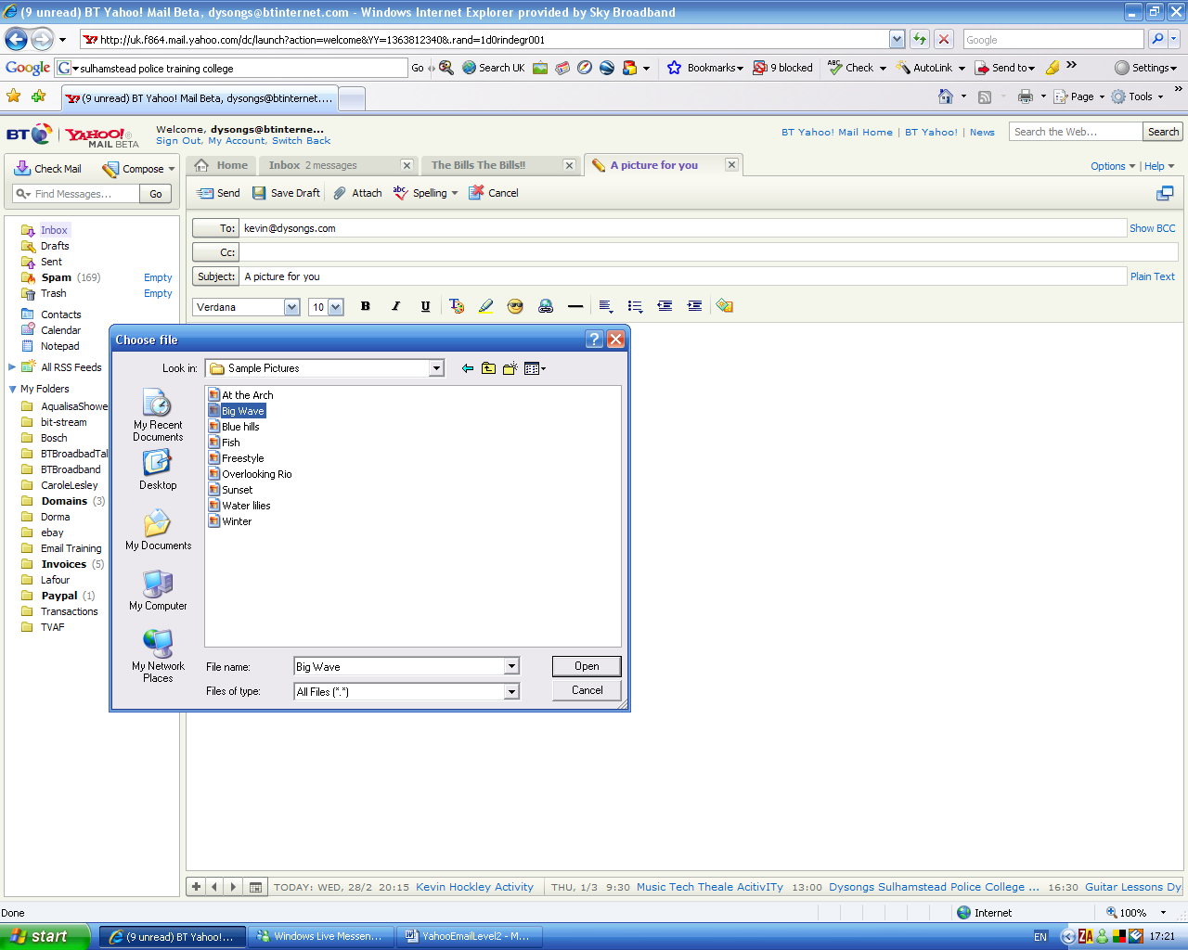

Now click Open

The email will attach the picture after it has scanned it for outgoing viruses in case one exists on your PC

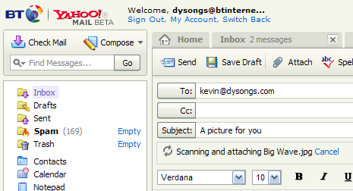

The picture is now attached to the email

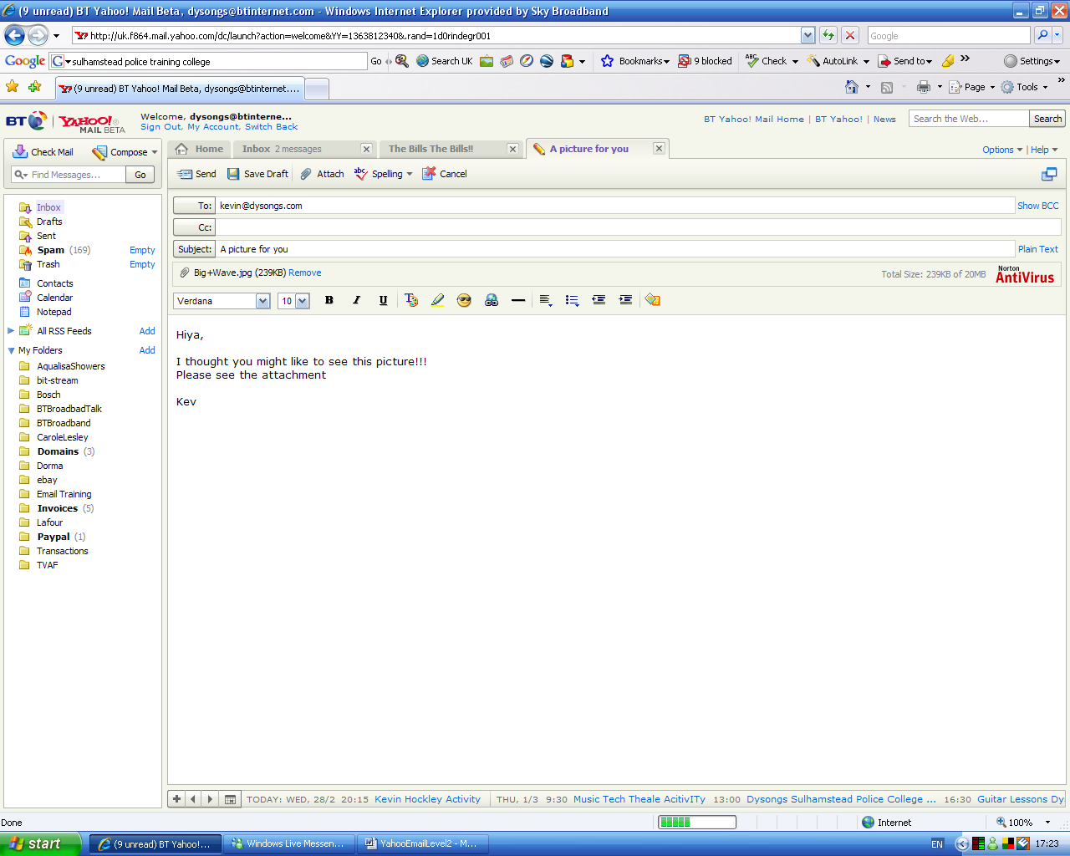

If you want to remove it before you send it (perhaps you attached the wrong picture) just click Remove

Now click Send and the email together with your attached picture file will be sent

Note:-

Sometimes it is not possible to send large files as attachments because some email programs and some ISPs place a restriction on the size of emails that go through their servers.

Also if your large file does get through to your recipient, it may cost them a lengthy phone call charge to receive it if they have not got a fast broadband Internet link

You might also fill up your recipient inbox size quota by sending them a large attachment. If this is the case you will paralyse their email!!!!

Usually files of 5Mb or less are quite okay to send although people who are still on dial up will still wait quite a while to receive your file.

Receiving and opening an email attachment

If you receive an email, you can see if there is an attachment included with it because the email appears in the inbox with a paperclip (the universal symbol for an attachment) is shown in the far left column

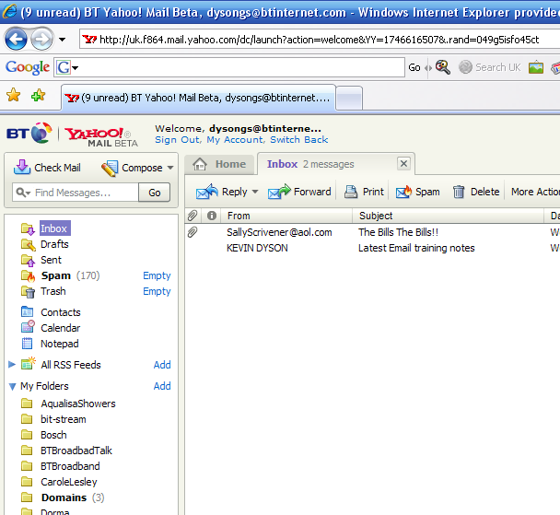

When you open the email you will also see the paperclip icon at the top of the email together with the name of the file that has been sent to you.

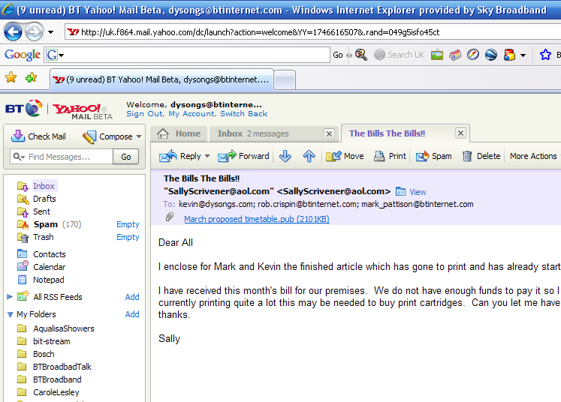

Notice that the file name is underlined which means that you can click it to open it

Click the file name to open it and it will be scanned for incoming viruses
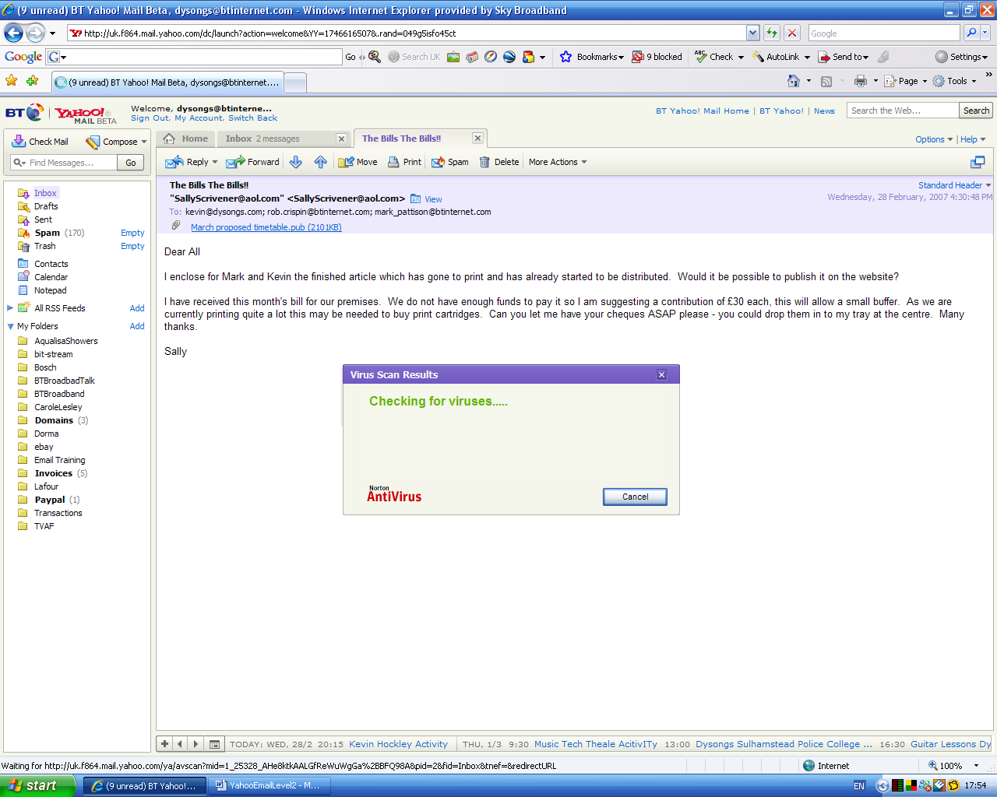

After scanning has finished click Download Attachment

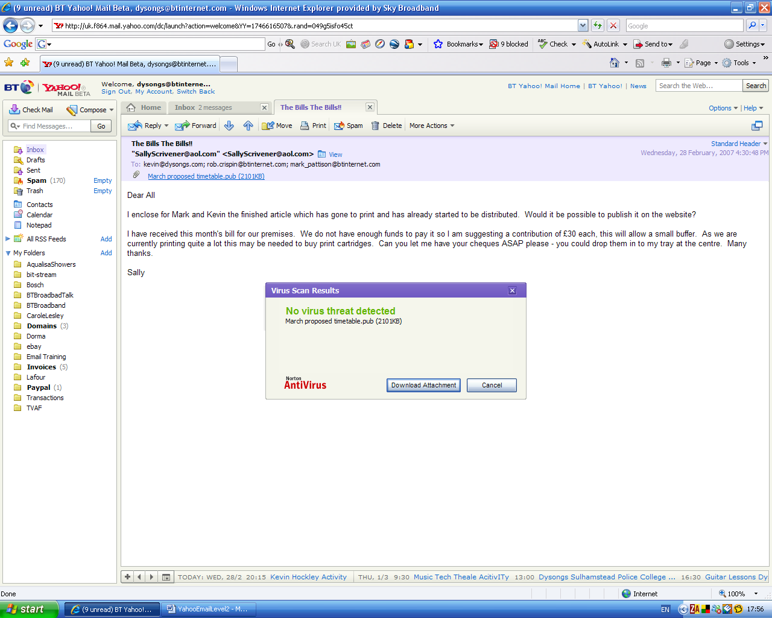

Another window will open giving you two choices.

You can either….

Open – open it now temporarily to view or listen to it

Or

Save it permanently to your PC so you can find it and open it later

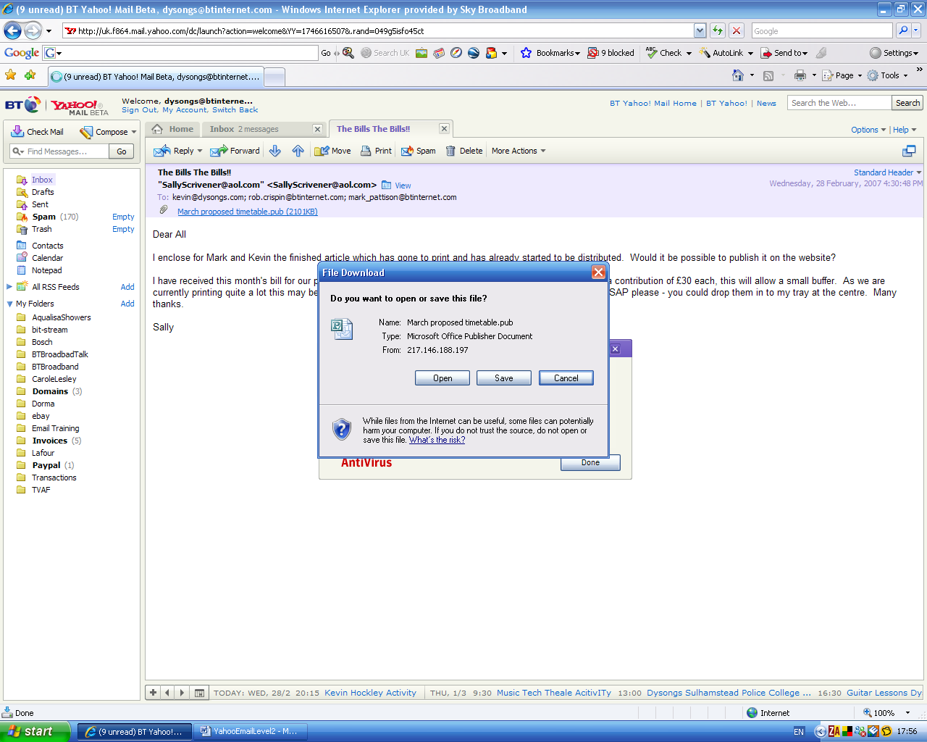

Choose Open

The file will look for it’s original programme on your computer – in this case Microsoft Publisher, open it and load the file into the programme to enable you to view it

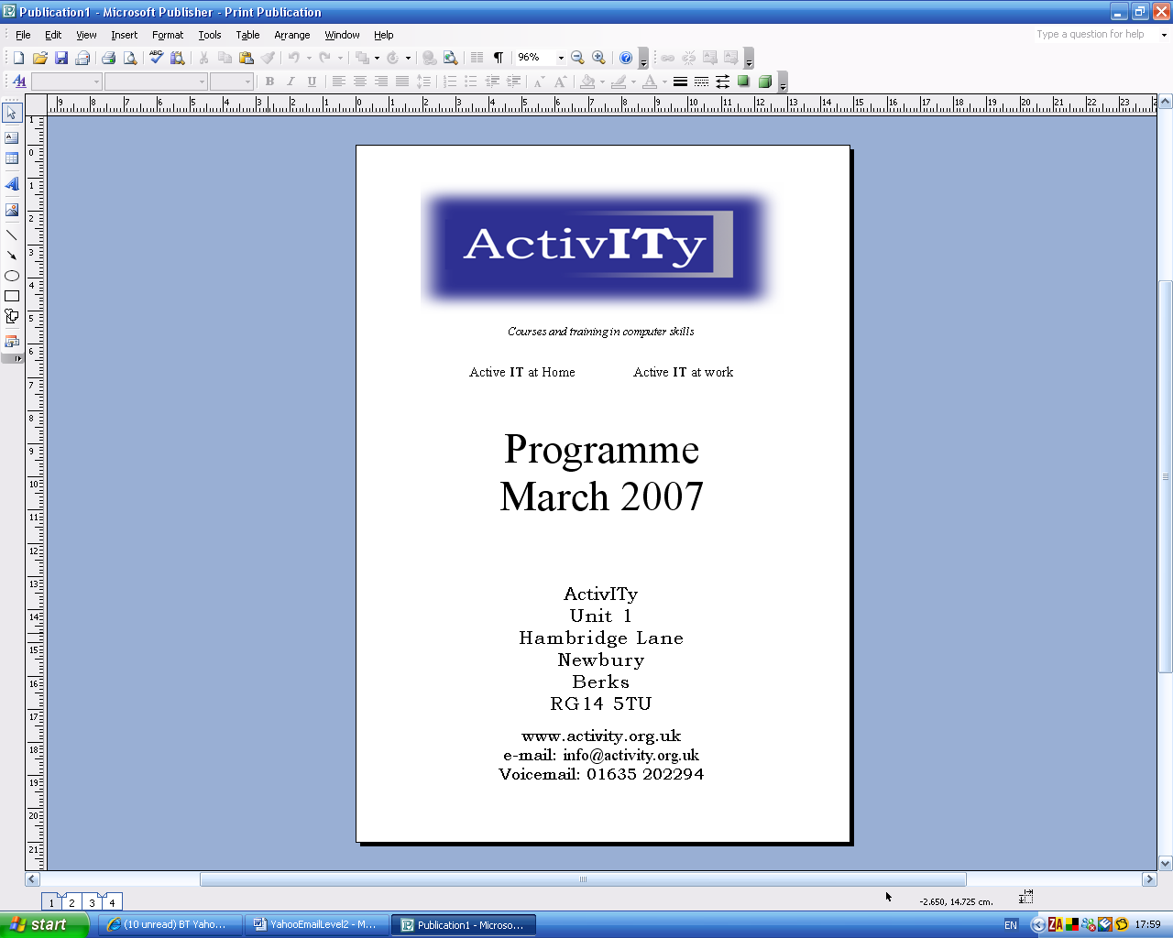

If you want to, you can now save the file permanently on your PC by clicking
File then Save As and choosing a folder to save it in.

Remember only open attachments from people you know and trust!

4. Searching through your email

- There may be times that you need to get back to an email someone has sent to you, or that you sent to them but you cant think where it might be in your collection of emails.

- To help you, you can use the email search facility

- In this scenario I want to find an email that contained the word ‘cyber’ as in cyber space as I remember someone sent me an email with this either in the title of the email or within the text body of the email

So type the word cyber in the search field

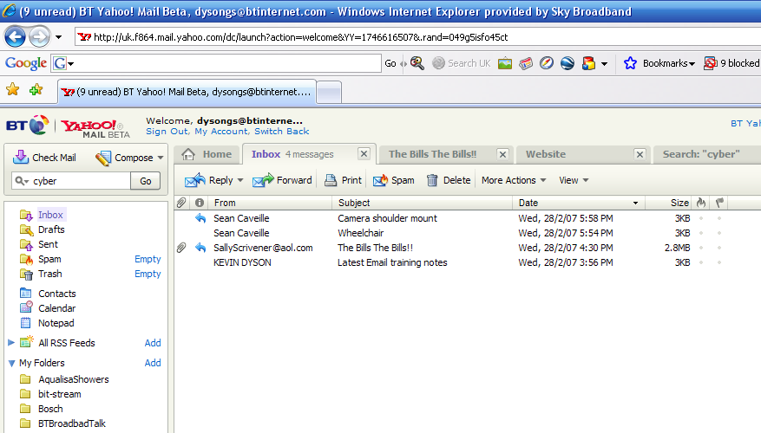

Press Go

The search results are returned for you

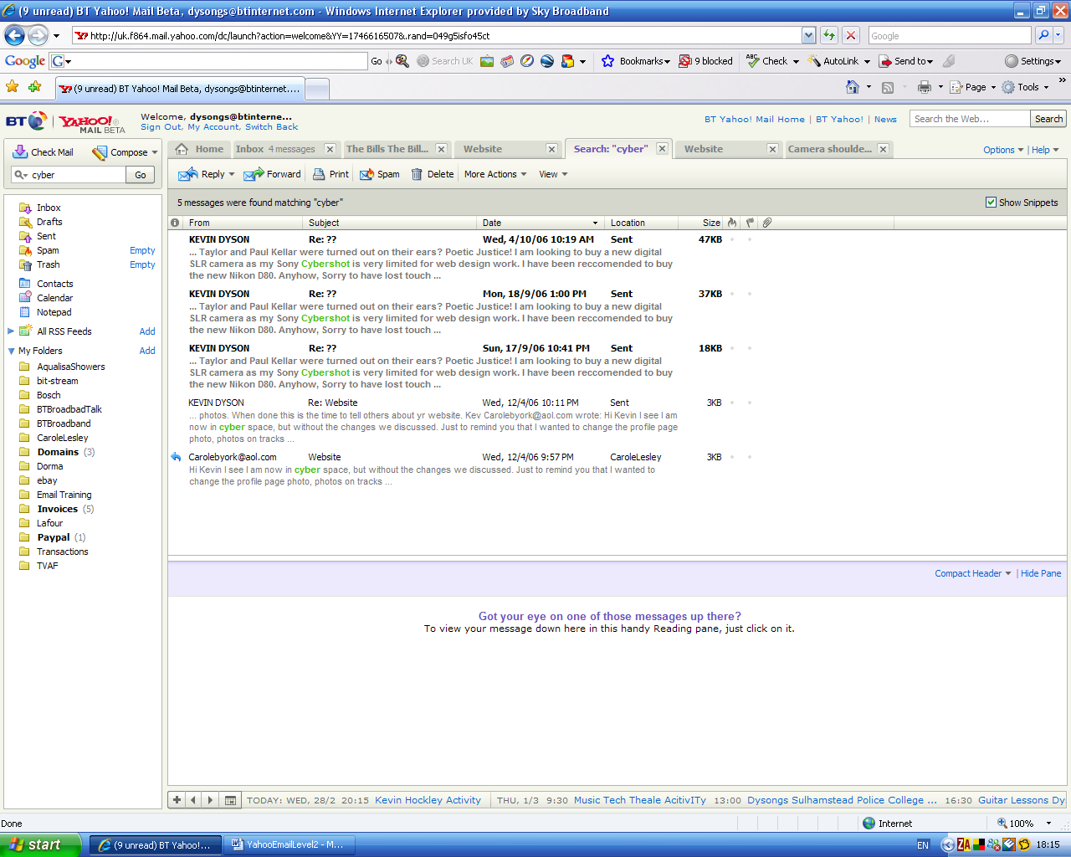

This was the one I was looking for

I can click to preview the actual email or double click to fully open it

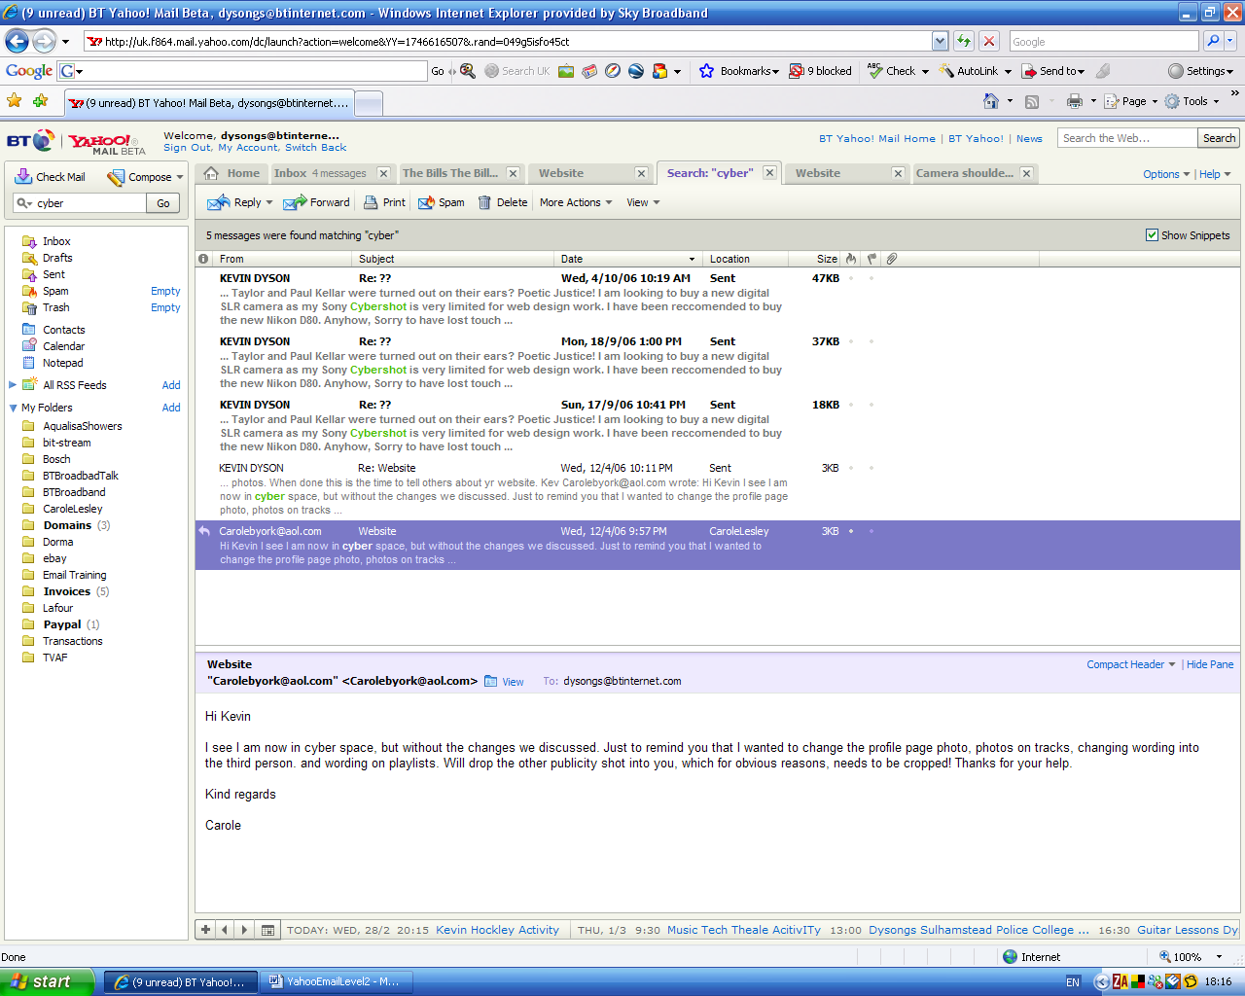

- Search searches thru ALL of the folders including the Inbox and Sent items but not the Trash or Spam

          - Setting up an email distribution list

            - Sometimes users have a special set of people, like family or a group of friends that they often want to send the same email out to

            - Although you can pick each person from your Contacts or even type in their long email addresses, this can be time consuming and laborious, particularly as you might have to do this several times a week.

            - For the investment of a little extra time to set up an email group, you will be able to address your next email to your group in a single click and this will save you a great amount of time from now on

            - The scenario is that I need to send an email to a group of people (my band) every time a booking comes in to let them know about it. There are 5 other members in the band besides myself. I don’t need to include me as my email will be recorded in my Sent folder anyway.

But I also want to include my friend from the BBC but need to add his name to my contacts as he is not yet in there

So before I send the next email to them, I will set up a group distribution list.
I can have as many of these distribution lists as I like, and each list might contain the some of the same people.

I also need to think of a name for this list that will jog my memory so that I will know exactly who I’m sending to

Setting up the list

When I click on Contacts a complete list of my known contacts are displayed

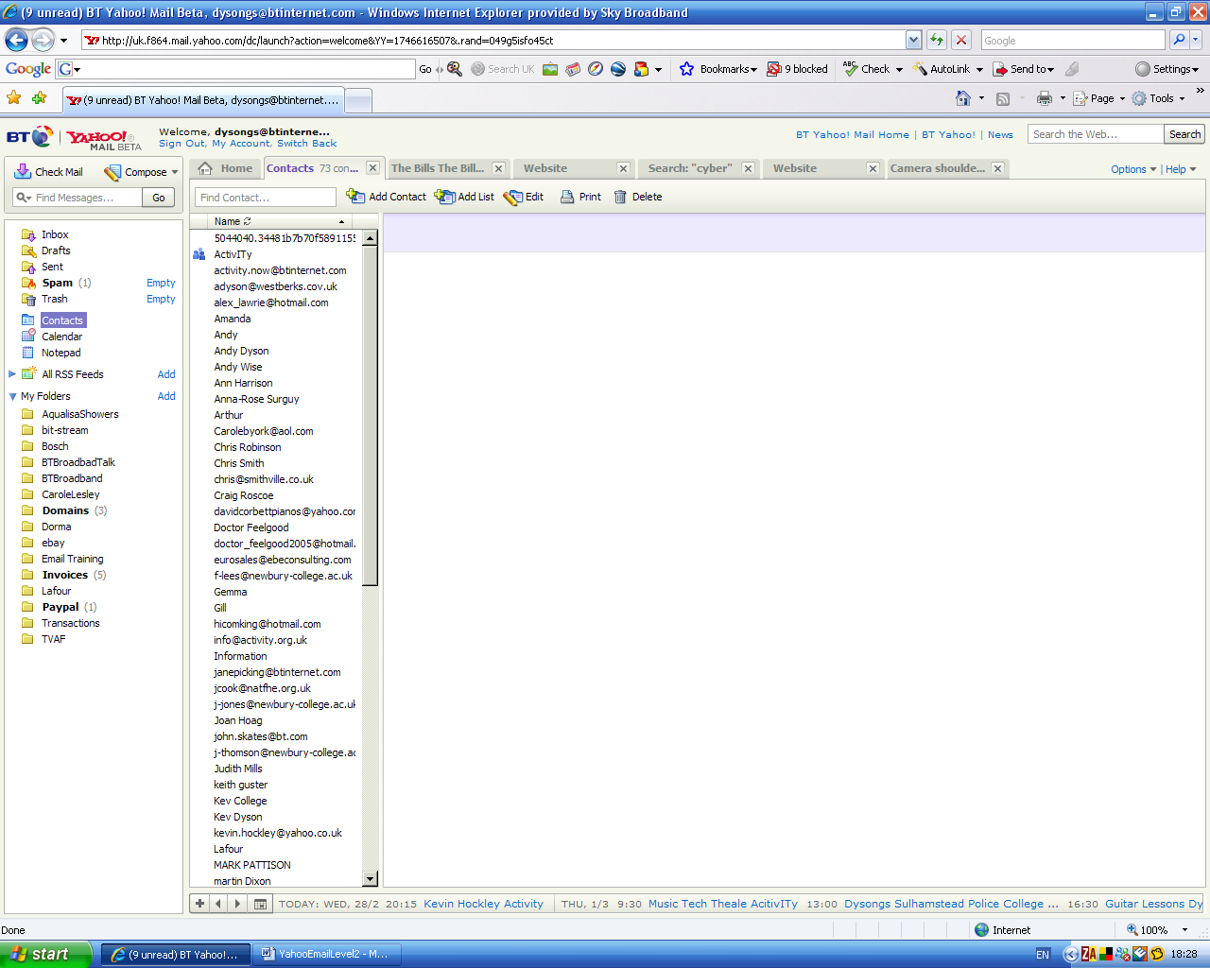

Usually new contacts are added to my list automatically as I send an email to them or reply to an email from them

I can add a contact myself by clicking Add Contact

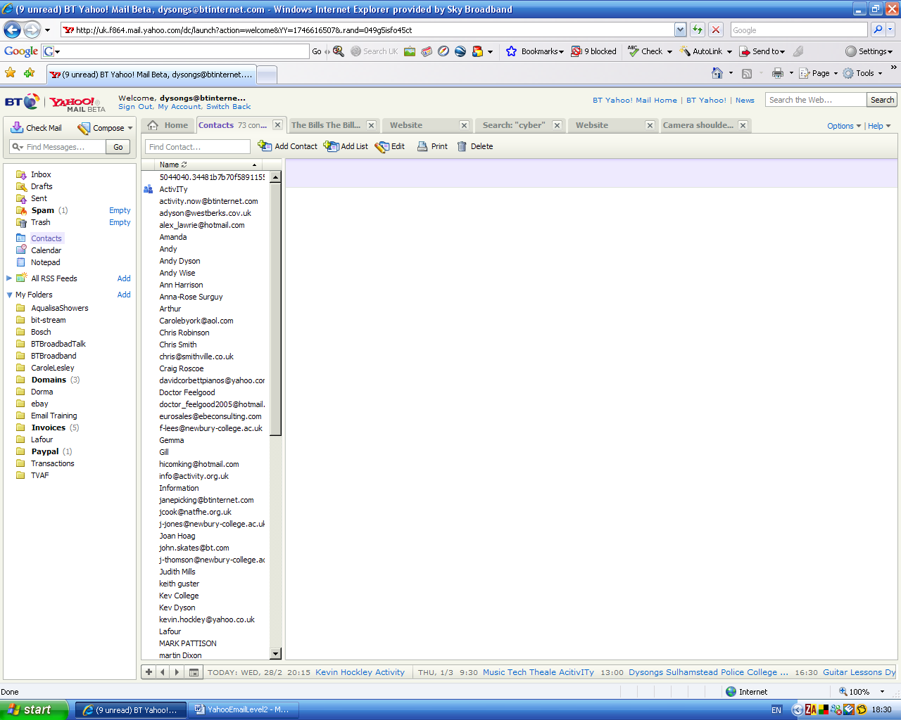

I fill out the form offered to me as below, note that it is important to include a name and an email address. I have also added a couple of phone numbers too.

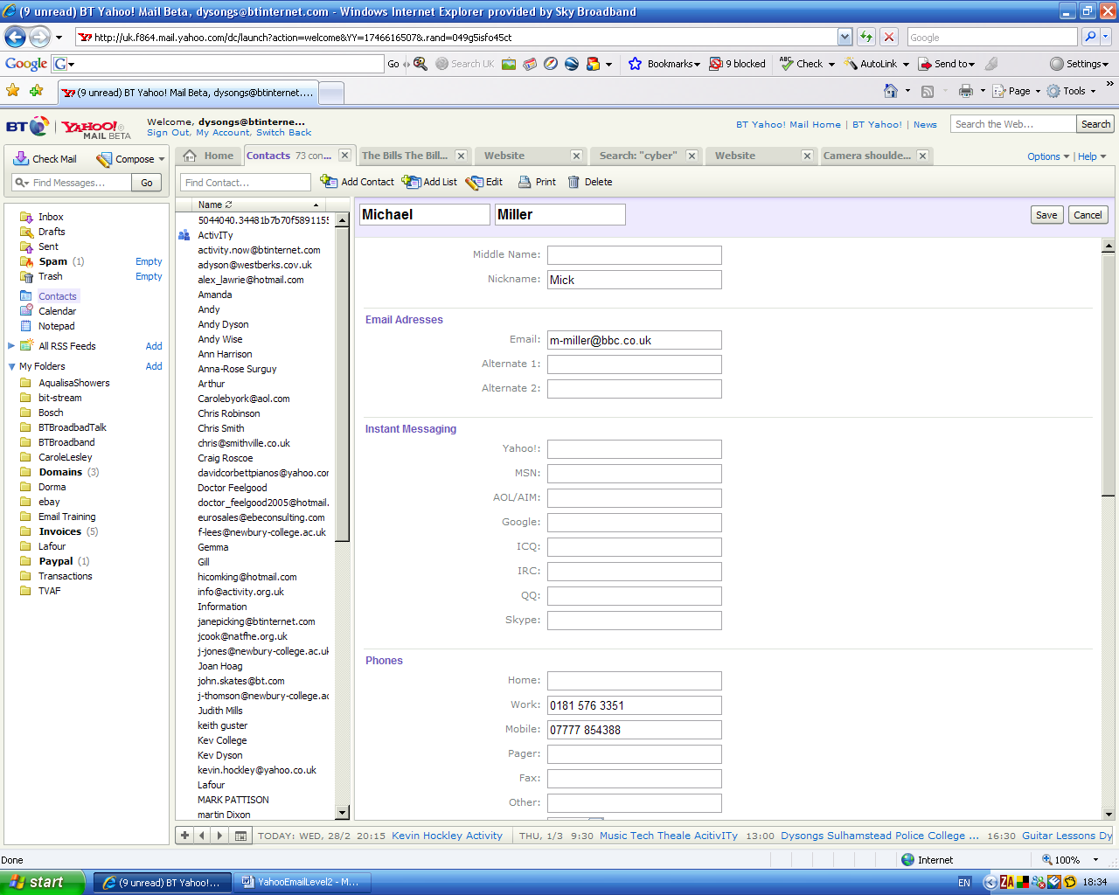

Now click Save and the person will be added to my contacts list

So now all my band members and my extra friend live in my contacts. I can now set up a distribution list.

Click Add List

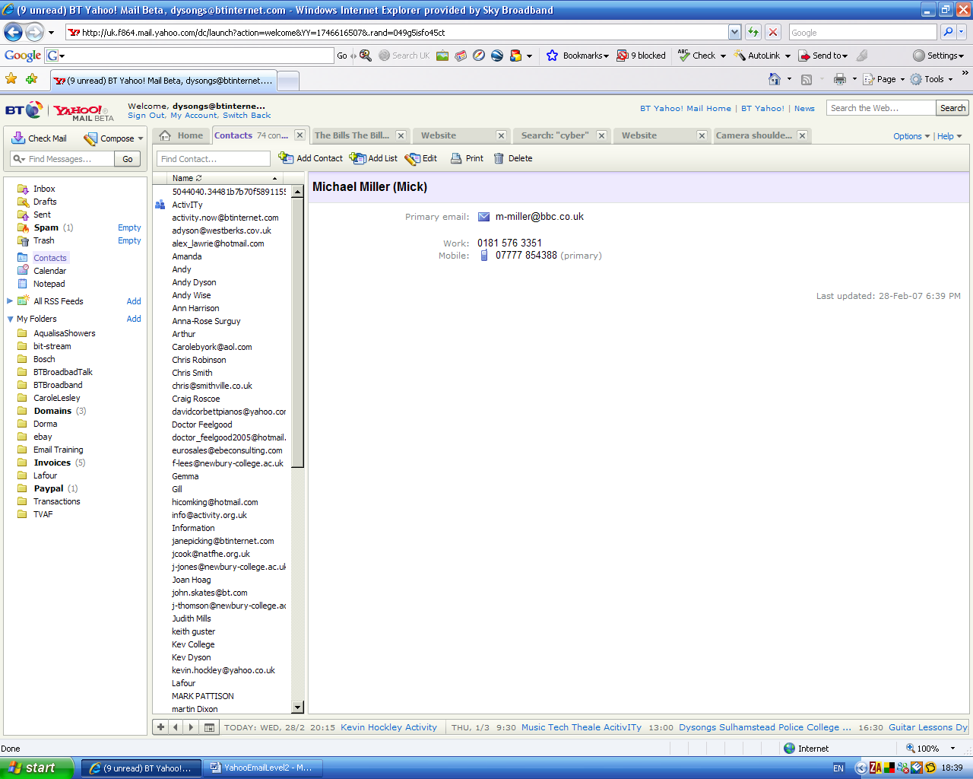

I now add the name of my new list (i.e. the name of the group which will appear in my Contacts for me to pick) I’ll call the list QuartzBand

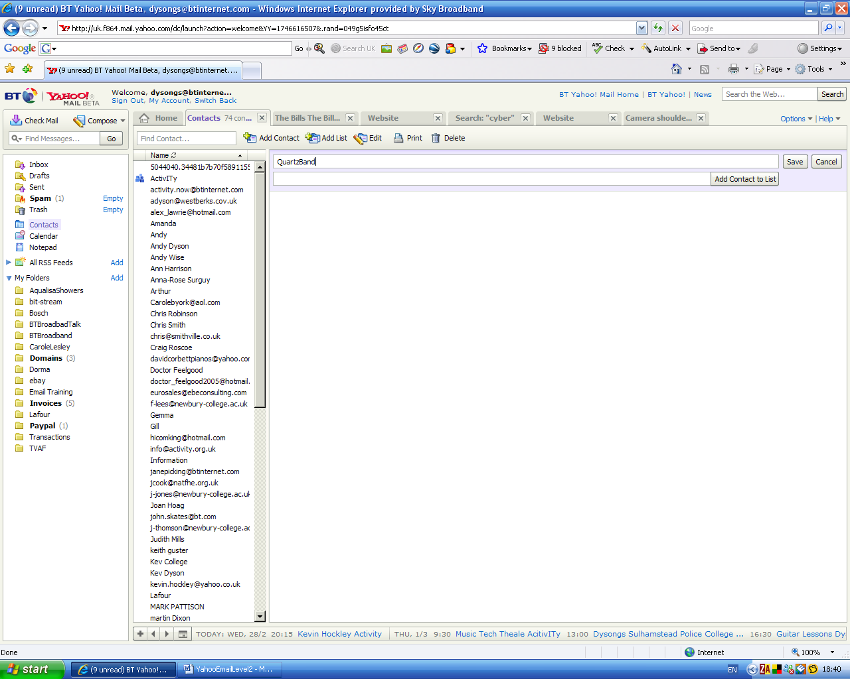

Now I want to add my first contact to my new list. It is Keith Guster

As soon a I type K in the Add Contact to List field, a collection of email address and names beginning with K appears

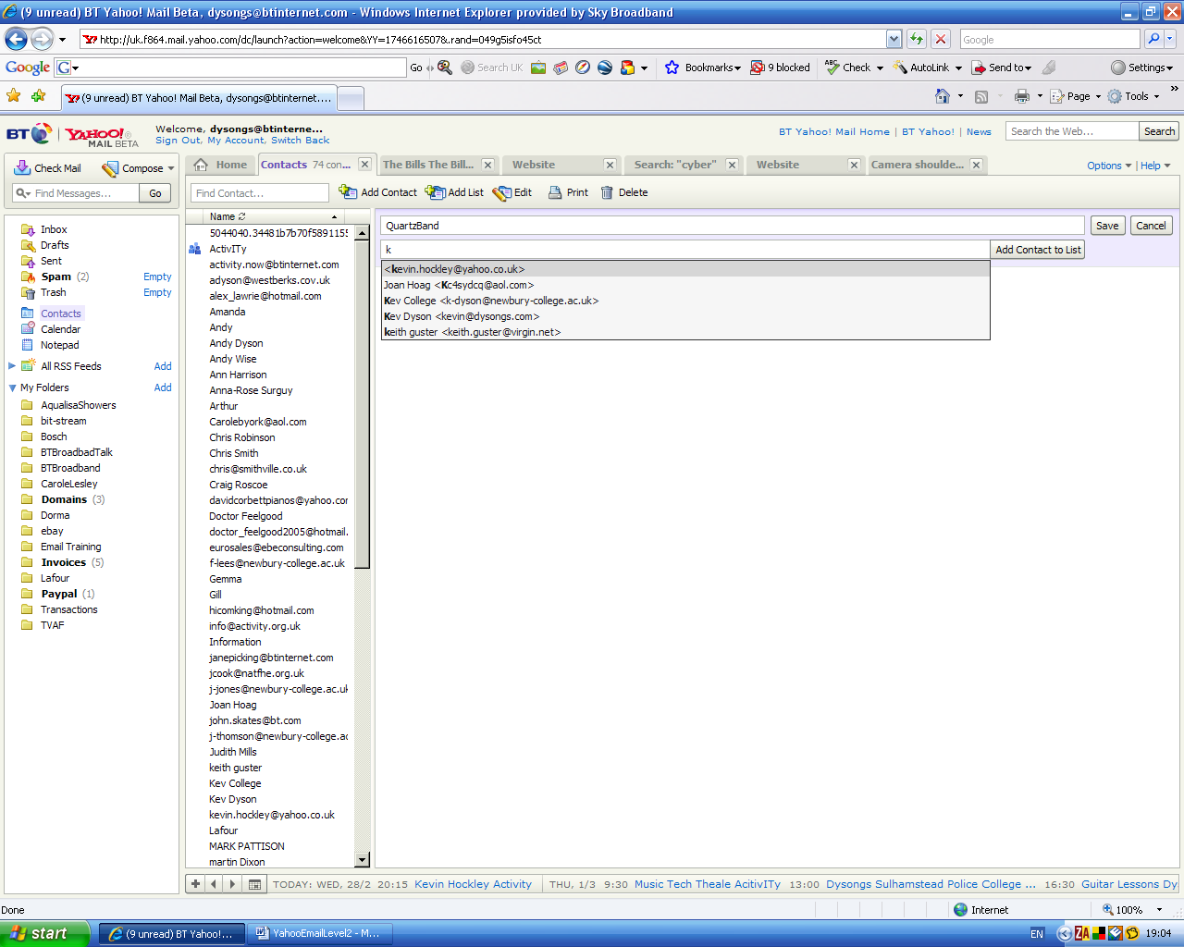

Simply by clicking on Keith Gusters entry he is added to my list

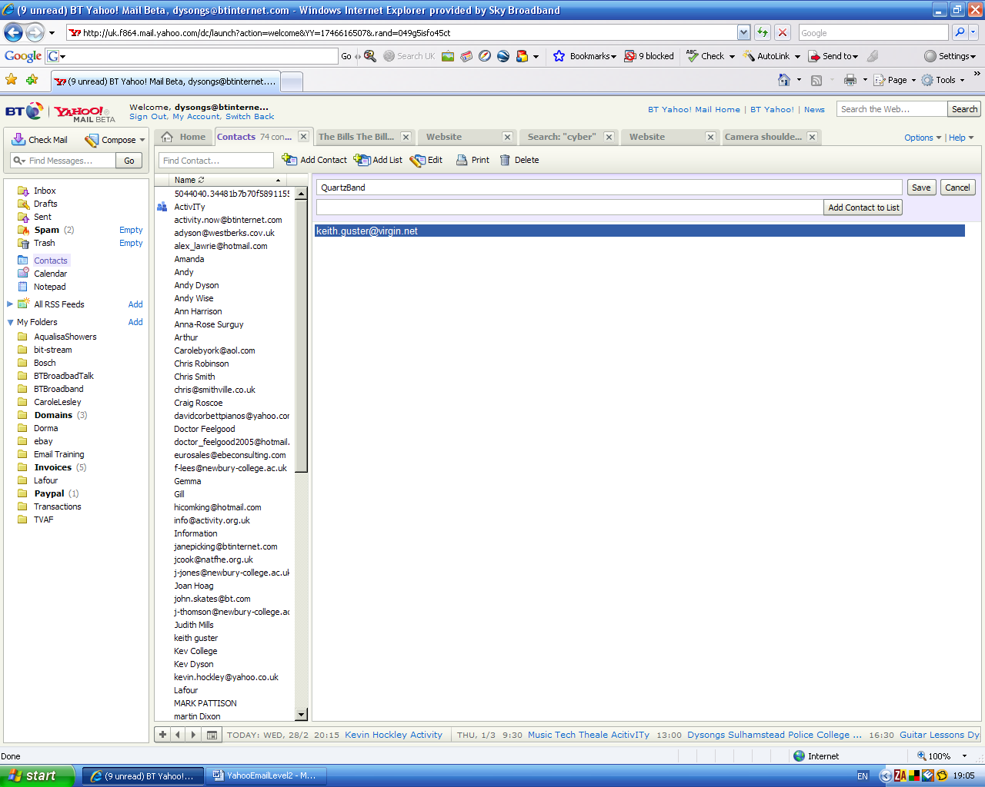

I now want to add Martin Dixon and so the same procedure is followed until all of my required contacts are listed in my list

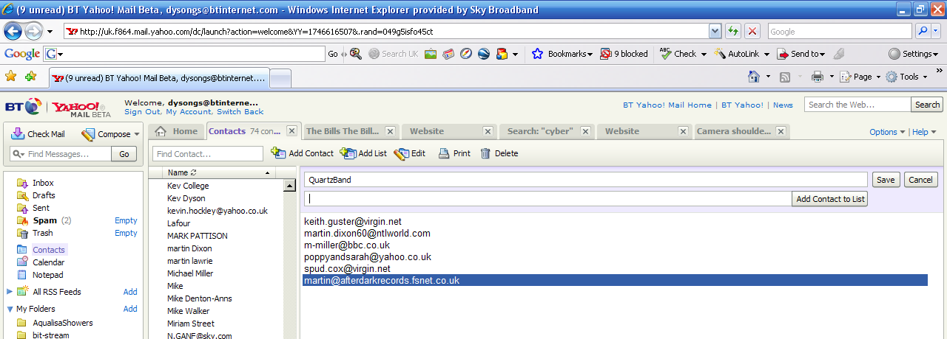

Now click Save to save my list

The list is displayed for me

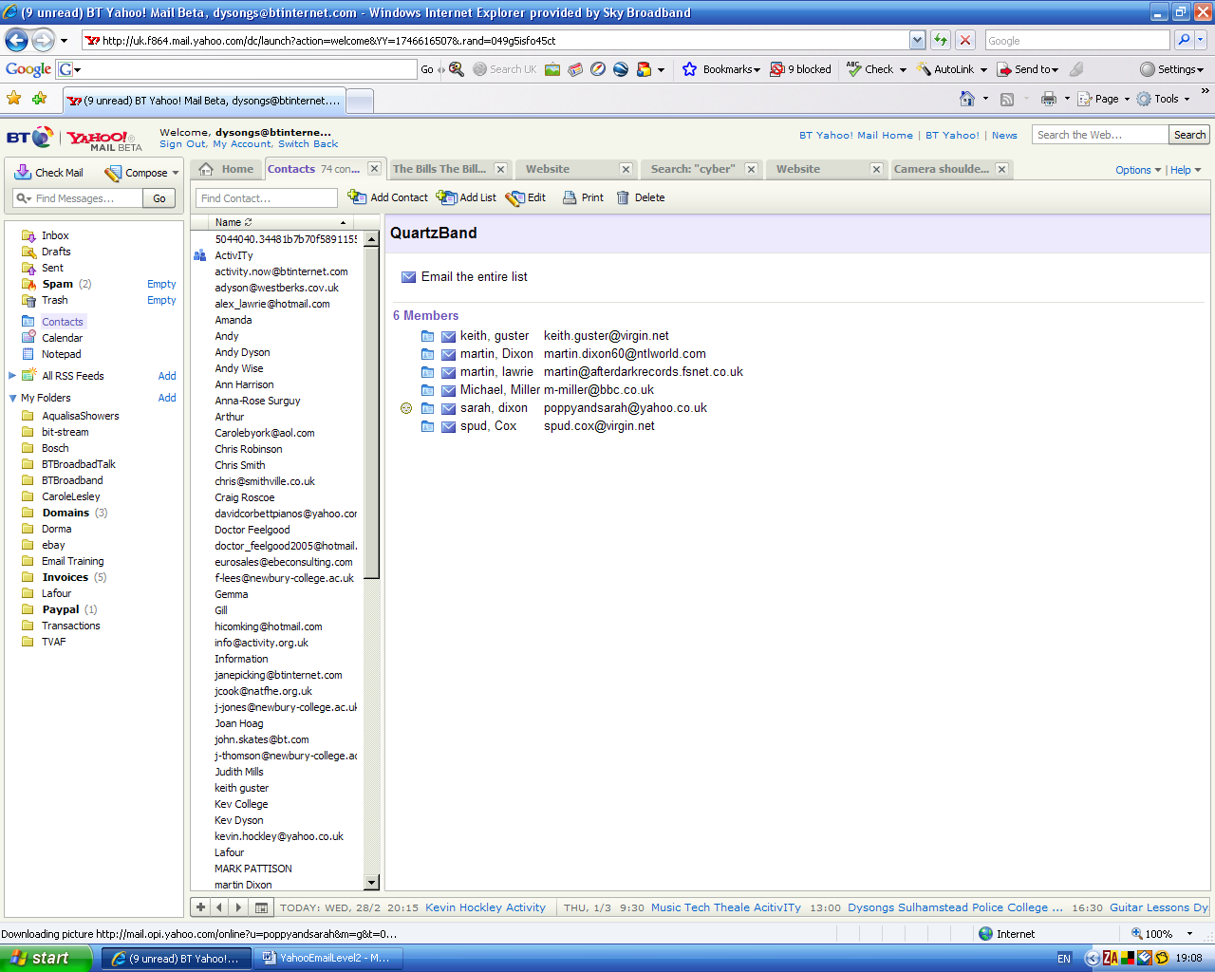

If I want to add more or remove someone I simply use Edit

I now need to send an email to the group so I click on Compose as normal

I then click on the To button

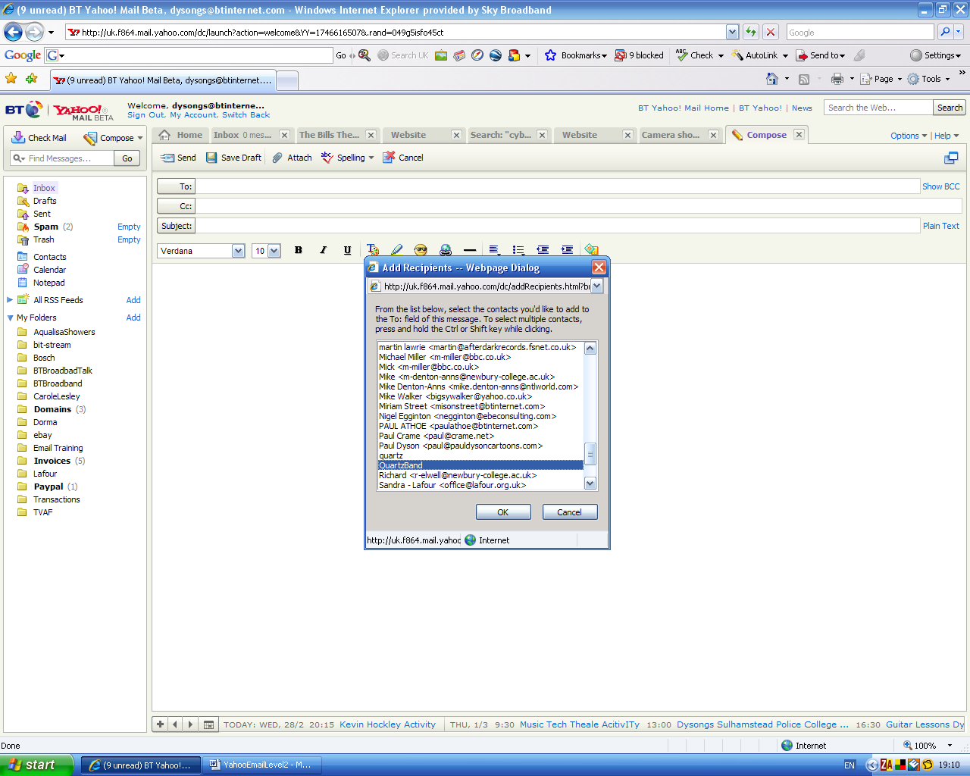

And find my email distribution list QuartzBand and click OK

The QuartzBand list (which contains the six member entries I added) is placed into the To field

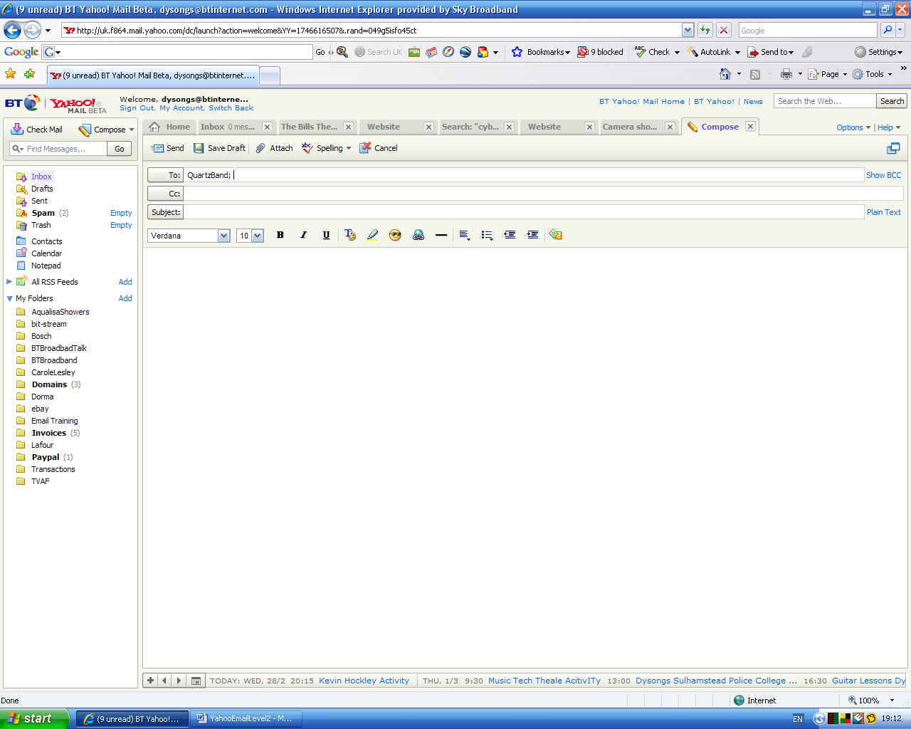

I can now complete and send my email as normal knowing that it will go to all members.

Note…

I don’t have to set up a list if I want to send my email to many people, I can still individually add as many recipients as I like to any email. But setting up a distribution list will save me a lot of time in the future if I find myself doing it regularly.

